Joint CQSE & NCTS Seminar

2022
Mar. 04, Friday

TIME Mar. 04, 2022, 2:30~3:30pm
TITLE Non-linear optics with superconducting quantum circuits
SPEAKER Professor. Watson Kuo (Professor, Department of Physics, National Chung Hsing University)
PLACE NCTS Physics Lecture Hall, 4F, Chee-Chun Leung Cosmology Hall, NTU

Abstract:

Nonlinear media for electromagnetic wave propagation is the foundation of various key components in quantum information processing, working for signal mixing, amplifying, and rectifying. Several categories of superconducting quantum circuits can present the desired non-linearity: superconductors with large kinetic inductance, Josephson junctions and Josephson meta-materials, and quantum systems with artificial atoms. In this talk, I will briefly introduce their working principles and provide some examples we have been working on, including high impedance resonators based on atomic scale epitaxial film, Josephson junction chains and Josephson parametric amplifiers, and coupled transmon artificial atoms.
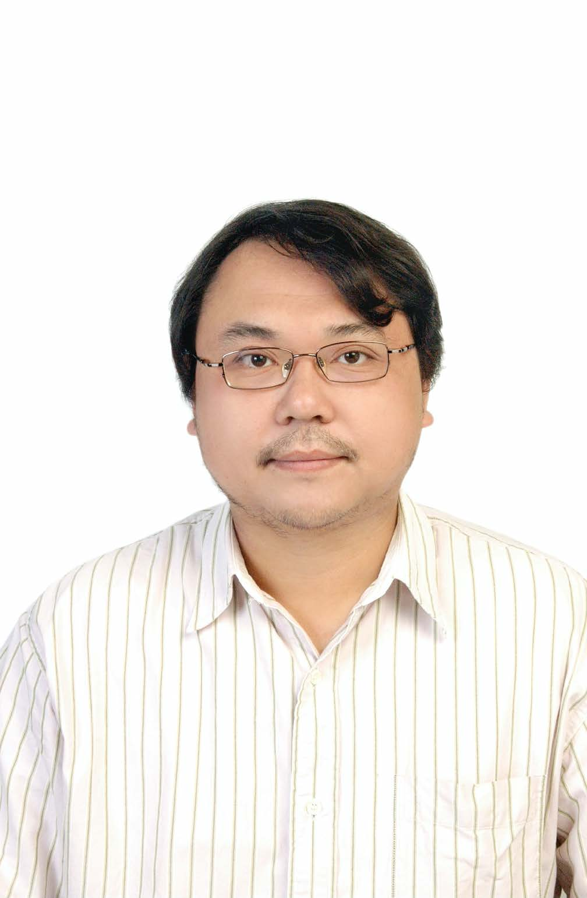
Biography Brief:

Professor Watson KUO
Department of Physics and Institute of Nanoscience
National Chung Hsing University
Taichung 402 Taiwan
E-mail: wkuo@phys.nchu.edu.tw
Lab Website: https://sites.google.com/site/nchuqdl/home

Education:
1998 – 2002 Ph. D., Department of Physics, National Tsing Hua University
1994 – 1996 M.S., Department of Physics, National Taiwan University
1990 – 1994 B.S., Department of Physics, National Taiwan University

Professional Appointments:
2012 Feb. – Professor, Department of Physics, National Chung Hsing University
2021 Aug. – Joint Appointment Research, Institute of Physics, Academia Sinica
2021 Dec. – Vice Dean, The Office of R&D, National Chung Hsing University
2019 Aug. – 2021 Nov. Chair, Department of Physics and Institute of Nanoscience, NCHU
2016 Aug. – 2020 Jul. Distinguished Professor, Department of Physics, NCHU
2016 Feb. – 2020 Jan. Board of Directors, the Physical Society of Taiwan
2016 Mar. – 2016 Jul. Visiting professor, Karlsruhe Institute of Technology, Germany
2011 – 2016 Division Chief, Research Center for Sustainable Energy and Nanotechnology, NCHU
2007 – 2012 Associate Professor, Department of Physics, National Chung Hsing University
2004 – 2007 Assistant Professor, Department of Physics, National Chung Hsing University.
2002 – 2004 Postdoctoral fellow, Institute of Physics, Academia Sinica

Fields of academic specialty:
1. Superconducting quantum device/circuit and quantum information applications.
2. Charge transport in nanomaterials: single electronics and metal-insulator transitions.
3. Development of bio and chemical sensors.
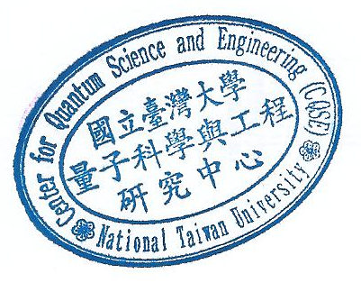
4. Microwave Metamaterials

