Joint CQSE & NCTS Seminar

2022
Mar. 11, Friday

TIME Mar. 11, 2022, 2:30~3:30pm
TITLE Quantum computing with silicon-based quantum-dot spin qubits
SPEAKER Dr. Chia-Hsien Huang (Department of Physics, National Taiwan University)
PLACE NCTS Physics Lecture Hall, 4F, Chee-Chun Leung Cosmology Hall, NTU
Abstract:
Using the spin of a single electron in a semiconductor quantum-dot as a physical qubit for quantum computation was first proposed by Loss and DiVincenzo in 1998. Early research on the qubits focused on the III-V semiconductors such as GaAs, but the coherence time was limited by the strong dephasing from the environment nuclear spins with the intrinsic dephasing time T_2^⋆~10 ns. In 2014, the T_2^⋆ was improved to ~120 μs by using the silicon-based quantum-dots for fewer than 5% of natural silicon atoms carry a nuclear spin. From then on, most research on this field switches to the silicon-based platforms. In 2020, the operating temperature for the qubits at ~1.5 kelvin was demonstrated to pave the way for large-scale quantum computation. In 2022, the single-qubit gate fidelity and the two-qubit gate fidelity both exceed the threshold (99%) of the error correction codes. Besides, the entangled three-qubit GHZ state is demonstrated in the three-qubit device. All these progresses, combining with the smaller footprint of the quantum dot ~100 nm×100 nm and the compatible fabrication process with the standard CMOS technologies, prove that the silicon-based quantum-dot qubits are the promising candidates for realizing large-scale practical quantum computation. In this talk, I’ll introduce the basics of the silicon-based quantum computing and the important progresses of the system. Finally, I’ll report my research on the high-fidelity and robust quantum gates for the quantum-dot spin qubits in silicon. Biography Brief:
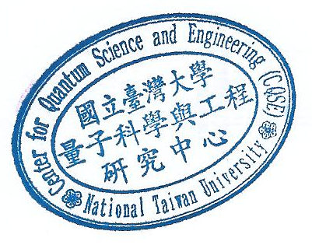
Chia-Hsien Huang received his Ph.D. in 2017 from Department of Physics, National Taiwan University. His research area is in quantum computation. Currently, he is a postdoctoral fellow of National Taiwan University, and focuses on developing high-fidelity and robust quantum gates for semiconductor quantum-dot spin qubits and superconducting qubits.

