Joint CQSE & NCTS Seminar

2022
Mar. 25, Friday

TIME Mar. 25, 2022, 2:30~3:30pm
TITLE Electronic Quantum Transport in Graphene Superlattice
SPEAKER Associate Professor, Ming-Hao Liu (Department of Physics, National Cheng Kung University)
PLACE NCTS Physics Lecture Hall, 4F, Chee-Chun Leung Cosmology Hall, NTU

Abstract:
Electrons in graphene behave like massless Dirac fermions due to the close analogy between its electronic structure that can be well described by the Dirac equation and the energy dispersion of photons in vacuum governed by the Planck-Einstein relation. When a spatially periodic potential that varies in a length scale much longer than the lattice constant of graphene is applied, its conic band structure is strongly modified, forming the so-called miniband structure in the resulting graphene superlattice. Depending on the origin of the underlying periodic potential, there are different types of graphene superlattices, each exhibiting more complicated transport behaviors than simple graphene. This talk gives an overview of our recent progress on quantum transport simulations for various types of graphene superlattices, including hBN/graphene moiré superlattices [1,2], gate-controlled two-dimensional [3] and one-dimensional [4] superlattices, and twisted graphene layers [5,6]. Most of the reviewed works are in collaboration with transport experiments.

[1] S.-C. Chen et al., Communications Physics 3, 71 (2020).
[2] R. Kraft et al., Phys. Rev. Lett. 125, 217701 (2020).
[3] R. Huber et al., Nano Lett. 21, 8046 (2020).
[4] W.-H. Kang et al., Phys. Rev. B 102, 195432 (2020).
[5] P. Rickhaus et al., Science Advances 6, no. 11, eaay8409 (2020).
[6] A. Mrenca-Kolasinska et al., 2D Mater. 9, 025013 (2022).

Biography Brief:
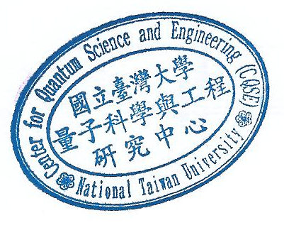
Professor Ming-Hao Liu received his MS and PhD in Physics from National Taiwan University, Taiwan. From 2011 to 2013, he was an Alexander von Humboldt Postdoctoral Fellow in University of Regensburg, Germany, where he continued his postdoctoral research until 2016. In 2017, he returned to Taiwan to join the Department of Physics of National Cheng Kung University as Assistant Professor, and was promoted to Associate Professor in 2019. In 2021, he was awarded Ta-You Wu Memorial Award.

