Joint CQSE & NCTS Seminar

2022
Apr. 01, Friday

TIME Apr. 01, 2022, 2:30~3:30pm
TITLE Quantum imaging with cameras
SPEAKER Assistant Professor, Paul-Antoine Moreau (Department of Physics, National Cheng Kung University)
PLACE NCTS Physics Lecture Hall, 4F, Chee-Chun Leung Cosmology Hall, NTU
Abstract:
The emergence and improvement of single-photon-sensitive cameras that can characterize spatial correlations of quantum nature lead to the rapid development of quantum imaging. This not only allowed imaging schemes that exhibit image improvements over classical methods to be devised, but also led to fundamental demonstrations performing the fast characterization of high dimensional entangled states. I'll introduce a few examples of research using such cameras together with quantum states of light to perform both fundamental quantum imaging demonstrations and practical imaging improvements.
Biography Brief:
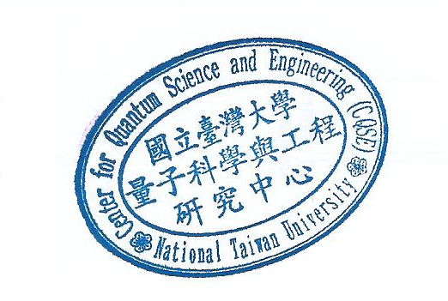
Paul-Antoine Moreau obtained his PhD at the FEMTO-ST institute in France in 2015. He went on to do a Postdoc at the University of Bristol, UK, within Quantum Engineering Technology Labs. After obtaining an individual Marie Curie Fellowship from the European Union he moved to the University of Glasgow, UK, to pursue his research on quantum imaging. He was later awarded a Leverhulme Trust Early Career Research Fellowship to continue his research at the University of Glasgow. He started to work at NCKU, Taiwan, in 2021 as an Assistant Professor.

