Joint CQSE & NCTS Seminar

2022
May. 20, Friday

TIME May. 20, 2022, 2:30~3:30pm
TITLE New quantum transport properties in artificial two-dimensional nanoarchitectures – Theoretical predictions and experimental realizations
SPEAKER Assistant Professor, Ching-Hao Chang (Department of Physics, National Cheng Kung University)
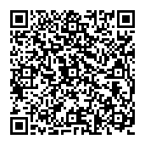
PLACE Online: https://nationaltaiwanuniversity-zbh.my.webex.com/nationaltaiwanuniversity-zbh.my/j.php?MTID=m3efd6c4a404b85f1e7a186a89d9b9009

Abstract:
We have learned fundamental magneto-transport effects including ordinary Hall effect and Aharonov–Bohm effect in general physics and in quantum physics, respectively. Our recent works, however, predict these effects can be created artificially in nonmagnetic system in the absence of external magnetic field. In this talk, I will introduce (1) high-order Hall effect can be driven by the nanomembrane corrugations [1,2], and (2) the nontrivial phase naturally occurs in the quantum states of radial superlattices including carbon nanoscroll [3]. I will also introduce the related experimental observations that confirm our predications.
[1] S.-C. Ho, C.-H. Chang, Y.-C. Hsieh, S.-T. Lo, B. Huang, C. Ortix, and T.-M. Chen, "Hall effects in artificially corrugated bilayer graphene without breaking time-reversal symmetry",
Nature Electronics 4, 116 (2021).
[2] B. Huang, A. G. Moghaddam, J. I. Facio, C.-H. Chang,, "Resonant Nonlinear Hall Effect in Two-Dimensional Electron Systems",
Phys. Rev. B 104, 165303 (2021).
[3]Y. J. Zhong, A. Huang, H. Liu, H.-T. Jeng, J.S. You, C. Ortix, C.-H. Chang, "Magnetoconductance modulations due to interlayer tunneling in radial superlattices",
Nanoscale Horizons 7, 168 (2022).

Biography Brief:
Education
09/2007 - 03/2012: PhD. in Physics, National Tsing-hua University, Taiwan.
09/2005 - 07/2007: M.S. in Physics, National Tsing-hua University, Taiwan.
09/2001 - 07/2005: B.S. in Biomedical Engineering and Environment Sciences,
National Tsing-hua University, Taiwan.
Work Experiences
08/2018 – current: Assistant Professor at Department of Physics, National Cheng Kung
University, Taiwan.
01/2018 – 07/2018: Principal Investigator in Institute for Theoretical Solid State Physic,
Leibniz Institute for Solid State and Materials Research, Germany.
10/2015 – 12/2017: Postdoc in Institute for Theoretical Solid State Physic,
Leibniz Institute for Solid State and Materials Research, Germany.
07/2015 - 10/2015: Postdoc in Research Center for Applied Sciences, Academia Sinica, Taiwan.
04/2012 - 06/2015: Postdoc in Physics Department, National Tsing-hua University, Taiwan.

Research interest
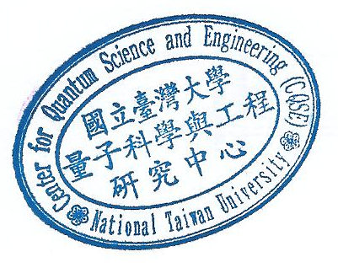
Spintronics, Magnetism in nanoscale, Transport in advanced nanoarchitectures

