Joint CQSE & NCTS Special Seminar

2022
Oct. 07, Friday

TIME Oct. 07, 2022, 2:30~3:30pm
TITLE Generalized master equation approach to dynamical steady states of a strongly driven two-level system
SPEAKER Post Doctoral Research, Jian-Zhang Chen (Department of Physics, National Taiwan University)
PLACE Rm104, Chin-Pao Yang Lecture Hall,

CCMS & New Physics Building, NTU
ONLINE https://nationaltaiwanuniversity-zbn.my.webex.com/

Abstract:
We apply an exact generalized master equation (GME) and a high-frequency approximated GME to describe the steady-state transmission at probe frequency of a driven two-level system, a superconducting circuit with the persistent current circulating coherently between clockwise and anticlockwise in the loop, interacting with a bosonic photon bath. Comparing the results obtained using these two GMEs with those from a recent superconducting flux qubit experiment and its corresponding theoretical approximated GME method, we find that the original parameter set used in the experiment and theoretical method is not in the high-frequency parameter regime. By using the exact GME with a slight adjustment on temperature and the proportionality factor strength in the original experimental parameter set as a function of driving strength, we find that a reasonably well fit to the experimentally measured steady-state probe transmission data can be achieved. Our exact GME approach does not require the Laplace transform with the pump-averaged kernels employed in their approximated GME method, and can still describe the experimental results of driving-induced bath-modified Bessel patterns in the experiment. This demonstrates that the exact GME approach is a correct and efficient tool to describe the steady-state properties of a driven spin-boson model in the case of strong system-environment coupling.
Biography Brief:
Education:
國立臺灣大學 物理系博士畢業 2017/01
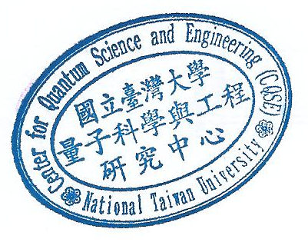
國立臺灣大學 物理系博士後研究-研發替代役 2017/03～2020/01
國立臺灣大學 物理系博士後研究 2020/01～now

