Joint CQSE & NCTS Special Seminar

2022
Oct. 14, Friday

TIME Oct. 14, 2022, 2:30~3:30pm
TITLE Matrix concentration in quantum simulation and quantum dynamics
SPEAKER Mr. Chi-Fang Chen (California Institute of Technology)
PLACE Rm104, Chin-Pao Yang Lecture Hall,
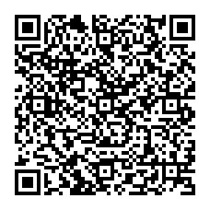
CCMS & New Physics Building, NTU
ONLINE https://nationaltaiwanuniversity-zbn.my.webex.com/

Abstract:

The Hilbert space is large, but an important structure is locality: physical Hamiltonians are often a sum over k-body terms. In this talk, I will draw connection between locality and matrix concentration in two different examples: quantum simulation using product formula enjoys an average-case v.s. worst case speedup [2111.05324]; Quantum dynamics in power-law interacting systems can be qualitatively different in the worst case and average case [2105.09960][2001.11509][1907.07637].

Biography Brief:
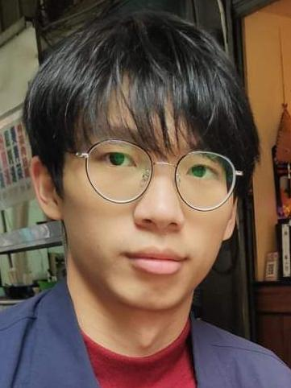
I am Chi-Fang Chen (陳麒方), a physics Phd Student at California Institute of Technology advised by Fernando G.S.L Brandao. My research focuses on the interplay between math and physics in quantum information theory and quantum dynamics, where vague phenomena in physics become provable in simple concrete models. Topics include quantum dynamic bounds, random matrix theory, thermodynamics, and quantum simulation. Before Caltech, I studied at NTU physics in the last year of high school. I was a physics (but defacto math) major at Stanford University and worked in Patrick Hayden's group.
