Joint CQSE & NCTS Special Seminar

2022
Oct. 21, Friday

TIME Oct. 21, 2022, 2:30~3:30pm
TITLE Development of Quantum Processor with Fluxonium Type
Superconducting Qubits
SPEAKER Assistant Prof. Yen-Hsiang Lin (Department of Physics, National TsingHua University)
PLACE Rm104, Chin-Pao Yang Lecture Hall,
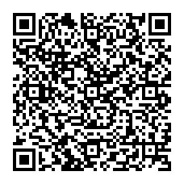
CCMS & New Physics Building, NTU
ONLINE https://nationaltaiwanuniversity-zbn.my.webex.com/

Abstract:

In a universal quantum processor, quantum states of quantum bits can be operated by well-defined quantum logic gates. Superconducting circuits is one of the promising candidates of hardware platform for quantum processors. Fluxonium and other similar type of superconducting qubits have long coherence time, large anharmonicity, and rich energy levels.
In this talk, I will introduce the basic concept of Fluxonium and Blochnoium superconducting qubits. We will further discuss about single-qubit gates, two-qubit gates in fluxonium type qubit systems.

Biography Brief:

Yen-Hsiang Lin is an assistant professor in the Department of Physics at
National TsingHua University (2020~Present). He got his B.S. degree in
National Taiwan University, Taiwan (2003) and received his PhD degree in
University of Minnesota (2011). He was postdoctoral researcher in University of Michigan (2011~2014) and postdoctoral researcher in University of Maryland (2014~2019). His current research interest is utilizing superconducting quantum circuit for quantum information applications.
