Joint CQSE & NCTS Special Seminar

2022
Oct. 28, Friday

TIME Oct. 28, 2022, 2:30~3:30pm
TITLE Quantum Information Processing with Photonic Integrated Devices
SPEAKER Associate Prof. Chih-Sung, Chuu (Department of Physics, National TsingHua University)
PLACE Rm104, Chin-Pao Yang Lecture Hall,
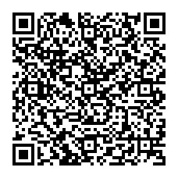
CCMS & New Physics Building, NTU
ONLINE https://nationaltaiwanuniversity-zbn.my.webex.com/

Abstract:
Integrated photonic circuits has enabled many quantum technologies including the linear optical quantum computing. In this talk, I will present our recent efforts on using such approach for quantum search and producing very short single photons.
Biography Brief:

Chih‐Sung Chuu is currently an Associate Professor of physics at National Tsing Hua University and Center for Quantum Technologies, where he leads the Quantum Photonics Laboratory. His interests and expertise concern experimental quantum optics and quantum engineering, including the generation and applications of single and entangled photons, and the manipulation of the light–matter interaction at the single‐photon level.
