Joint CQSE & NCTS Special Seminar

2022
Nov. 29, Tuesday

TIME Nov. 29, 2022, 12:30~13:30pm
TITLE Simulating Stochastic Processes with Variational Quantum Circuits
SPEAKER Mr. Daniel Fink (University of Stuttgart, Germany)
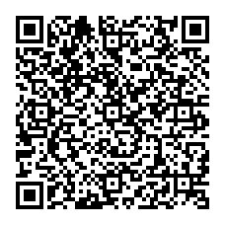
PLACE NCTS Physics Lecture Hall, 4F, Chee-Chun Leung Cosmology Hall, NTU
ONLINE https://nationaltaiwanuniversity-zbn.my.webex.com/

Abstract:
Simulating future outcomes based on past observations is a key task in predictive modeling and has found application in many areas ranging from neuroscience to the modeling of financial markets. The classical provably optimal models for stationary stochastic processes are so-called ϵ-machines, which have the structure of a unifilar hidden Markov model and offer a minimal set of internal states. However, these models are not optimal in the quantum setting, i.e., when the models have access to quantum devices. The methods proposed so far for quantum predictive models rely either on the knowledge of an ϵ-machine or on learning a classical representation thereof, which is memory inefficient. Meanwhile, variational quantum algorithms (VQAs) are a promising approach for using near-term quantum devices to tackle problems arising from many different areas in science and technology. Within this work, we propose a VQA for learning quantum predictive models directly from data on a quantum computer. As a proof of concept, we apply the algorithm to a stationary stochastic process and show that a suitable regularization leads to a small set of internal states and a constantly good simulation performance over multiple future time steps.
