Joint CQSE & NCTS Seminar

2022
Dec. 16, Friday

TIME Dec. 16, 2022, 14:30~15:30pm
TITLE Hybrid Quantum-Classical Machine Learning with Applications
SPEAKER Dr. Yen-Chi Chen (Senior software engineer at Wells Fargo Bank)
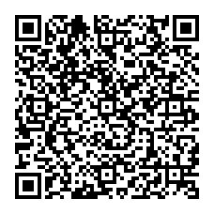
PLACE Rm104, Chin-Pao Yang Lecture Hall,
CCMS & New Physics Building, NTU
ONLINE https://nationaltaiwanuniversity-zbn.my.webex.com/

Abstract:
Recent advances in machine learning (ML) and quantum computing (QC) hardware draw significant attention to building quantum machine learning (QML) applications. In this talk, I will provide an overview of the hybrid quantum-classical machine learning paradigm. Important ideas such as calculating quantum gradients will be described. Then I will present the recent progress of QML in various application fields such as classification, distributed or federated learning, speech recognition, natural language processing and reinforcement learning. Potential advantages, scalability and use cases in the NISQ era will be discussed as well.

Biography Brief:
Dr. Samuel Yen-Chi Chen received the Ph.D. and B.S. degree in physics and the M.D. degree in medicine from National Taiwan University, Taipei City, Taiwan. He is now a senior software engineer at Wells Fargo Bank. Prior to that, he was an assistant computational scientist in the Computational Science Initiative, Brookhaven National Laboratory. His research interests include building quantum machine learning algorithms as well as applying classical machine learning techniques to solve quantum computing problems. He won the First Prize In the Software Competition (Research Category) from Xanadu Quantum Technologies, in 2019.

