Joint CQSE & NCTS Seminar

2023
Mar. 17, Friday

TIME Mar. 17, 2023, 14:30~15:30pm
TITLE Multiple Andreev-reflection assisted cooling effects in nano- superconducting Josephson junctions
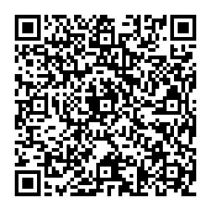
SPEAKER Prof. Jeng-Chung Chen
(Department of Physics, National Tsing Hua University)
PLACE NCTS Physics Lecture Hall, 4F, Chee-Chun Leung Cosmology Hall, NTU
ONLINE https://nationaltaiwanuniversity-zbn.my.webex.com/

Abstract:
We demonstrate the cooling effect induced by multiple-Andreev-reflection (MAR) in the thermal hysteresis of superconducting constrictions near clean and short limit. We measure the current-voltage ( I-V ) characteristics of single constriction and -SQUID devices, and observe a series of voltage-step jumps below the gap (). Our analysis shows that the voltage-steps are signs of the enhancement of superconductivity driven by excess I ; in particular, a MAR-assisted cooling effect taken place at V  /e. To illustrate the consequence of the cooling effect, we show the coexistence of normal current mediated by Andreev quasiparticles and Josephson supercurrent in the dissipative state of a -SQUID device. Our findings provide an insightful understanding of nonequilibrium quasiparticle relaxation in mesoscopic superconducting systems and have strong implications for developing superconducting ballistic devices.

Biography Brief:
2003 Ph.D. in Physics at Purdue University, U.S.A.
2004– 2006 Postdoctoral researcher at the University of Tokyo
2006- present Professor, Department of Physics, National Tsing-Hua University

