Joint CQSE & NCTS Seminar

2023
Apr. 28, Friday

TIME Apr. 28, 2023, 14:30~15:30pm
TITLE Using Master-to-Slave Injection Locked Laser Diodes for Quantum Key Distribution
SPEAKER Prof. Gong-Ru Lin
(Department of Electrical Engineering, National Taiwan University)
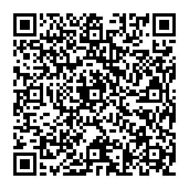
PLACE Rm104, Chin-Pao Yang Lecture Hall, CCMS & New Physics Building, NTU
ONLINE https://nationaltaiwanuniversity-zbn.my.webex.com/

Abstract:
In this talk, the fundamentals and technologies of quantum key distribution (QKD) based on semiconductor laser diodes will be reviewed and demonstrated for implementing the first prototype of Single-Photon QKD transmitter and receiver in NTU. Two different schemes of the QKD generators will be introduced through the exhibition of their key parameters and performances.

Biography Brief:

Gong-Ru Lin,
Y. Z. Hsu Science Chair Professor
Lifetime Distinguished Professor
Fellows of IEEE, OSA, SPIE, IET, IOP
Distinguished Research Fellow of MOST
13th President of Taiwan Photonics Society
Associate Dean, College of Electrical Engineering and Computer Science
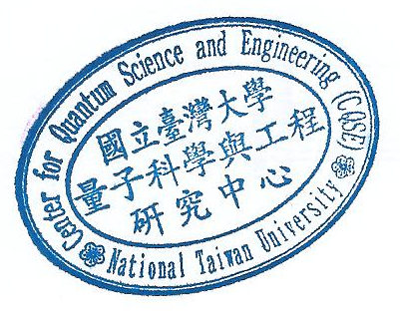
Graduate Institute of Photonics and Optoelectronics
Department of Electrical Engineering
National Taiwan University
OSA Traveling Lecturer and SPIE Visiting Lecturer
Senior/Associate Editor, IEEE Photonics Journal
Topical Editor, Optics Letters
No. 1, Sec. 4, Roosevelt Rd., Taipei 10617, Taiwan
E-mail: grlin@ntu.edu.tw
Web: http://scholar.google.com/citations?user=QfFMP0cAAAAJ&hl=en

