Joint CQSE & NCTS Seminar

2023
May. 05, Friday

TIME May. 05, 2023, 14:30~15:30pm
TITLE Quantum Simulators with Two Species of Atoms: Progress, Challenges, and Future Applications
SPEAKER Prof. Shih-Kuang Tung
(Department of Physics, National Tsing Hua University)
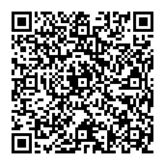
PLACE NCTS Physics Lecture Hall, 4F, Chee-Chun Leung Cosmology Hall, NTU
ONLINE https://nationaltaiwanuniversity-zbn.my.webex.com/

Abstract:
Atoms are ideal quantum objects; abundant in nature and each atom of the same kind is perfectly identical. Due to their universal properties, atoms have been used for quantum simulations for decades. With atomic quantum simulators, numerous important many-body models have been observed and studied, including the Superfluid-Mott insulator transition, Tonks-Girardeau gas, BEC-BCS crossover, and BKT transition in 2D atomic systems. As our ability to control these simulators advances, we also seek to add new complexity to them, for example, the integration of a second species. In this talk, I will report on our progress in creating a quantum simulator with two species of atoms and discuss our plans for future applications.

Biography Brief:
Shih-Kuang Tung
Department of Physics, National Tsing Hua University
101 Section 2 Kuang Fu Road, Hsinchu, Taiwan 30013
Office: (03) 5162582
zekest@phys.nthu.edu.tw
Ph.D. in Physics, JILA (University of Colorado at Boulder and NIST) 2010
Thesis: Probing an Interacting Bose Gas in a Quasi-Two-Dimensional Trap
Advisor: Prof. Eric Cornell
Appointments
• Assistant professor, National Tsing Hua University (Taiwan), 2016/8 – present
Publications
1. W.-X. L, Y.-D. Chen, Y. -T. Sun, S. Tung, and Paul S. Julienne, Feshbach resonanes in an ultracold
7Li133Cs Bose-Bose mixture, Phys. Rev. A, 106, 023317 (2022).
2. Y.-D. Chen, W.-X. Li, M.-E. Chou, C.-S. Kuo, C.-S. Li, and Tung, S., Lithium-cesium slow beam from
a two-dimensional magneto-optical trap, Phys. Rev. A 103, 023102 (2021).
3. S. Tung, K. Jim´enez-Garc´ıa, J. Johansen, C. Parker, and C. Chin, Geometric Scaling of Efimov States
in a 6Li133Cs Mixture, Phys. Rev. Lett., 113, 240402 (2014).
4. L.-C. Ha, C.-L. Hung, X. Zhang, U. Eismann, S. Tung, and C. Chin, Strongly Interacting TwoDimensional Bose Gases, Phys. Rev. Lett., 110, 145302 (2013).
5. S. Tung, C. Parker, J. Johansen, C. Chin, Y. Wang, and P. Julienne, Ultracold Mixture of 6Li and
133Cs Atoms with Tunable Interactions, Phys. Rev. A., 87, 010702(R) (2013).
6. X. Zhang, C.-L. Hung, S. Tung, and C. Chin, Observation of Quantum Criticality with Ultracold Atoms
in Optical Lattices, Science 335, 1070 (2012).
7. C.-L. Hung, X. Zhang, L.-C. Ha, S. Tung, N. Gemelke, and C. Chin, Extracting Density-Density
Correlations from In-Situ Images of Atomic Quantum Gases, New. J. Phys. 13, 075019 (2011).
8. X. Zhang, C.-L. Hung, S. Tung, N. Gemelke, and C. Chin, Exploring Quantum Criticality Based on
Ultracold Atoms in Optical Lattices, New. J. Phys. 13, 045011 (2011).
9. S. Tung, G. Lamporesi, D. Lobser, L. Xia, E. A. Cornell, Observation of Presuperfluid Regime in a
Two-Dimensional Bose Gas, Phys. Rev. Lett. 105, 230408 (2010).
10. V. Schweikhard, S. Tung, S, and E. A. Cornell, Vortex Proliferation in the Berezinskii-KosterlitzThouless Regime on a Two-Dimensional Lattice of Bose-Einstein Condensates, Phys. Rev. Lett. 99,
030401 (2007).
11. S. Tung, V. Schweikhard, and E. A. Cornell, Observation of Vortex Pinning in Bose-Einstein Condensates, Phys. Rev. Lett. 97, 240402 (2006).
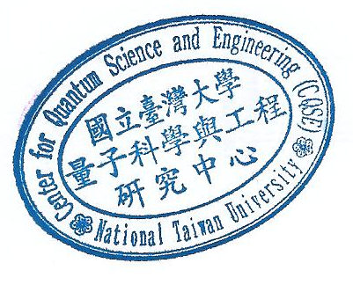
12. I. Coddington, P. C. Haljan, P. Engels, V. Schweikhard, S. Tung, and E. A. Cornell, Experimental
Studies of Equilibrium Vortex Properties in a Bose-Condensed Gas, Phys. Rev. A 70, 063607 (2004).
13. V. Schweikhard, I. Coddington, P. Engels, S. Tung, and E. A. Cornell, Vortex-Lattice Dynamics in
Rotating Spinor Bose-Einstein Condensates, Phys. Rev. Lett., 89, 210403 (2004).

