Joint CQSE & NCTS Seminar

2023
May 12, Friday

TIME May 12, 2023, 14:30~15:30pm
TITLE High-fidelity gates in Rydberg atoms and nonorthogonal coding using spectrally-entangled biphoton source
SPEAKER Dr. Hsiang-Hua Jen
(Institute of Atomic and Molecular Sciences, Academia Sinica)
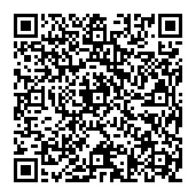
PLACE NCTS Physics Lecture Hall, 4F, Chee-Chun Leung Cosmology Hall, NTU
ONLINE https://nationaltaiwanuniversity-zbn.my.webex.com/

Abstract:
Here I will talk about two recent works on high-fidelity gates in Rydberg atoms and nonorthogonal coding scheme proposed in a biphoton source. The first work relates to the performance of two-qubit gates, which is essential and mandatory to build a large-scale quantum computer. Here we numerically investigate the time-optimal pulses to generate a high-fidelity Rydberg Cz in a three-level ladder-type atomic system. By tuning the temporal shapes of Gaussian or segmented pulses, the populations on the intermediate excited states are shown to be suppressed within the symmetric gate operation protocol, which leads to a high Bell fidelity up to 0.9998.
The second work relates to a nonorthogonal coding scheme in the spectral modes of the multiplexed photon pairs, where we present an architecture of multiple channels enabling a high-capacity transfer of codewords. Using the measures of the second-order correlations and associated visibility and contrast, we further quantify the performance of the proposed nonorthogonal coding scheme. Our results demonstrate the capability to encode and decode quantum information beyond the orthogonal coding scheme and the feature of error resilience.

Biography Brief:
Dr. Hsiang-Hua Jen:
-Mar 2020 – present Assistant research fellow, IAMS of Academia Sinica, Taiwan.
-Aug 2017 – Feb 2020 Assistant research scholar, IOP of Academia Sinica, Taiwan.
-Aug 2014 – July 2017 Postdoc, IOP of Academia Sinica, Taiwan.
-Aug 2013 – July 2014 Postdoc, TU of Kaiserslautern, Germany.
-Mar 2011 – July 2013 Postdoc, NTHU, Taiwan.
-Jan 2005 – Dec 2010 Doctorate, Physics, Georgia Institute of Technology.
-Aug 2003 – Dec 2004 MS, Physics, Georgia Institute of Technology.
-Jun 1996 – Jun 2000 BS, Physics, National Taiwan University.

· 2019 IOP Outstanding Reviewer for Journal of Physics B: Atomic, Molecular and Optical Physics
· Paper [Phys. Rev. A 95, 043840 (2017)] selected as Kaleidoscope in the issue of April 2017
2014 NCTS Best postdoc paper award, Taiwan
2012 NSC (now MOST) Postdoc academic publication award, Taiwan
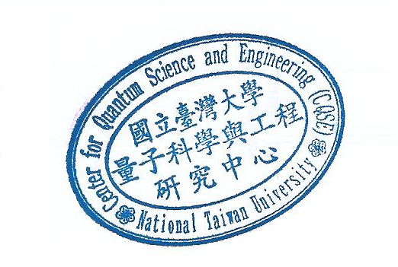
1996 ROC national contest for Asian Pacific Mathematics Olympiad (40 contestants nationally)

