Joint CQSE & NCTS Seminar

2023
May 26, Friday

TIME May 26, 2023, 14:30~15:30pm
TITLE Certifying the degree of quantum properties using black boxes
SPEAKER Prof. Shin-Liang Chen
(Department of Physics, National Chung Hsing University)
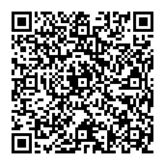
PLACE NCTS Physics Lecture Hall, 4F, Chee-Chun Leung Cosmology Hall, NTU
ONLINE https://nationaltaiwanuniversity-zbn.my.webex.com/

Abstract:
Quantum nonlocality is one of the most intriguing phenomena in quantum physics. Fundamentally, it tells us that nature's behavior is counter-intuitive to our daily-life experience. In practice, it is an extremely useful resource for realizing several remarkable quantum technologies, such as quantum computation and quantum communication. An important application of nonlocality is that it can be used for certifying the quantum properties of systems without making any assumptions about the devices. In this talk, I will briefly introduce such an idea and current research status. I will also present some of our recent research results, including black-box certification of quantum steerability, measurement incompatibility, temporal quantum steerability, and the quantum states themselves.

Biography Brief:
2022/02 to now
Assistant Professor, Department of Physics, National Chung Hsing University, Taichung, Taiwan
2019/04 - 2022/01
Visiting scholar, Dahlem Center for Complex Quantum Systems, Free University of Berlin, Berlin, Germany
2018/04 - 2019/03
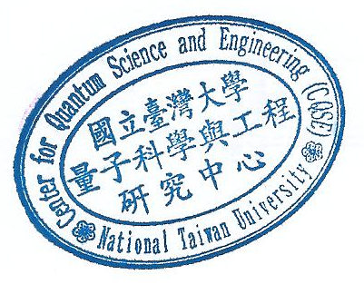
Postdoc, Max-Planck-Institute of Quantum Optics, Garching, Germany

2012/09 - 2017/01
PhD, National Cheng Kung University, Taiwan

