Joint CQSE & NCTS Seminar

2023
Jun. 02, Friday

TIME Jun. 02, 2023, 14:30~15:30pm
TITLE Adaptively partitioned analog quantum simulation for the nonclassical free induction decay of NV centers on near-term quantum computers
SPEAKER Prof. Hong-Bin Chen
(Department of Engineering Science, National Cheng Kung University)
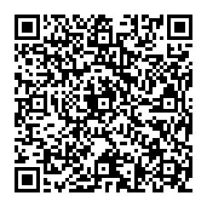
PLACE NCTS Physics Lecture Hall, 4F, Chee-Chun Leung Cosmology Hall, NTU
ONLINE https://nationaltaiwanuniversity-zbn.my.webex.com/

Abstract:
The idea of simulating quantum physics with controllable quantum devices had been proposed several decades ago. With the extensive development of quantum technology, large-scale simulation, such as the analog quantum simulation tailoring an artificial Hamiltonian mimicking the system of interest, has been implemented on elaborate quantum experimental platforms. However, due to the limitations caused by the significant noises and the connectivity, analog simulation is generically infeasible on near-term quantum computing platforms. Here we propose an alternative analog simulation approach on near-term quantum devices. Our approach circumvents the limitations by adaptively partitioning the bath into several groups based on the performance of the quantum devices. We apply our approach to simulate the free induction decay of the electron spin in adiamond NV− center coupled to a huge number of nuclei and investigate the nonclassicality induced by the nuclear spin polarization. The simulation is implemented collaboratively with authentic devices and quantum simulators on IBMQ. This work sheds light on a flexible approach to simulate large-scale materials on noisy near-term quantum computers.

Biography Brief:

Personal Profile:
Affiliation: Dept. of Eng. Sci., National Cheng Kung University Cell Phone: (886)985135573
E-mail : hongbinchen@gs.ncku.edu.tw

Education
Ph. D of Science
National Cheng Kung University, Tainan, Taiwan Physics: June, 2015

Master of Science
National Cheng Kung University, Tainan, Taiwan Physics: June, 2008

Bachelor of Science
National Cheng Kung University, Tainan, Taiwan Physics: June, 2006
Mathematics: June, 2006

Current Position and Relevant Experience
- Jan. 2023 ~ present, core member of the TG 1.3 of national center for theoretical science (NCTS)
- Aug. 2019 ~ present, Assistant professor, Department of Engineering Science, National Cheng Kung University
- Nov. 2015 ~ Jun. 2019, Postdoctoral research fellow, Department of Physics, National Cheng Kung University
- Mar. 2012 ~ Feb. 2013, Visiting Ph. D student at Albert-Ludwigs-Universität Freiburg, Germany. (NSC- DAAD scholarship)

Activities
- Organizer of Taiwanese-German Young Researchers Forum on Quantum Information Science (Feb. 17-19, 2023, NCKU)
- Organizer of Young Researchers Forum on Quantum Information Science (Feb. 9-11, 2022, NCKU).
- Organizer of Young Researchers Forum on Quantum Information Science (Jun. 29-30, 2018, NTHU).
- Organizer of Young Researchers Forum on Quantum Information Science (Jun. 23-24, 2017, NTHU).

Awards and Honors
- 2021 Research Day of College of Engineering-Young Scholar Thesis Competition-First Prize.
- 2018 MOST Best Research Paper Award for Postdoctoral Fellows.
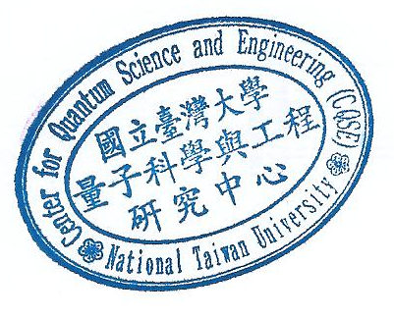
2018 NCTS Best Postdoc Paper Award.

