Joint CQSE & NCTS Special Seminar

2023
Jun. 27, Tuesday

TIME Jun. 27, 2023, 10:30~11:30pm
TITLE Quantum Neural Networks: Unlocking New Possibilities in Quantum Information Theory
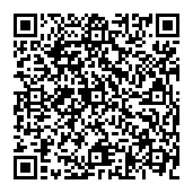
SPEAKER Prof. Bei Zeng (Department of Physics, Hong Kong University of Science and Technology and director of the IAS Center for Quantum Technologies)
PLACE Rm104, Chin-Pao Yang Lecture Hall, CCMS & New Physics Building, NTU
ONLINE https://nationaltaiwanuniversity-zbn.my.webex.com/

Abstract:
Quantum computers offer unprecedented capabilities for solving complex problems, positioning them as invaluable tools across diverse domains. A notable extension of classical neural networks, quantum neural networks (QNNs) leverage the unique features of quantum computers to push the boundaries of existing knowledge. This talk delves into recent progress in employing QNNs for addressing challenging problems within quantum information theory, such as detecting quantum entanglement, devising quantum query algorithms, identifying quantum error-correcting codes, and executing quantum state tomography. Furthermore, we will explore the potential of QNNs in enhancing the applicability of generative models, such as the Generative Pre-trained Transformer (GPT), for the analysis of quantum correlations. This presentation highlights the potential of QNNs as a promising direction for future research in quantum information theory.

Biography Brief:

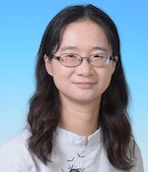
Bei Zeng is a quantum information theorist at the Hong Kong University of Science and Technology, where she is a professor of physics and director of the IAS Center for Quantum Technologies. As well as quantum information, her research interests include quantum computing and quantum error correction. Bei is a 2002 graduate of Tsinghua University, where she studied physics and mathematics. After earning a master’s degree in Physics at Tsinghua in 2004, she completed a Ph.D. in physics in 2009 at MIT. She became a postdocoral fellow at the Institute for Quantum Computing, University of Waterloo, before becoming an assistant professor at the Department of Mathematics and Statistics at the University of Guelph in 2010, rising through the academic ranks there to become a full professor in 2018. She moved to her current position at the Hong Kong University of Science and Technology in 2019. In 2021, Bei was named a fellow of American Physical Society (APS), after a nomination from the APS Division of Quantum Information (DQI).
