Joint CQSE & NCTS Special Seminar

2023
Aug. 04, Friday

TIME Aug. 04, 2023, 14:30~15:30pm
TITLE Simulating large-size quantum spin chains on cloud quantum computers
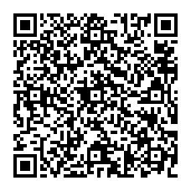
SPEAKER Prof. Tzu-Chieh Wei (Stony Brook University)
PLACE NCTS Physics Lecture Hall, 4F, Chee-Chun Leung Cosmology Hall, NTU
ONLINE https://nationaltaiwanuniversity-zbn.my.webex.com/

Abstract:
Quantum computers have the potential to efficiently simulate other quantum systems, especially when their size is large and classical simulation is not feasible. Despite the total qubit number reaching beyond one hundred in several existing quantum devices, their applicability is still plagued by the prevalent noise and errors. Here we present an analysis of a physics-motivated variational ansatz for the XXZ spin chain and report realizations on various IBM quantum computers to simulate ground states of quantum spin chains with qubit numbers ranging from 4 to 102. The estimated ground-state energies from these experiments across different backends and with varying sizes of system reach the expected values within a few error percentages. The enabling factors for accurate large realizations include the use of short-depth physics-motivated ansatzes and efficient and scalable energy measurement and error mitigation, particularly using a reference state in the zero-noise extrapolation.

Ref: Phys. Rev. Research 5, 013183 (2023)Phys. Rev. Research 5, 013183 (2023)

Biography Brief:
Education
PhD Physics, University of Illinois at Urbana-Champaign (UIUC), October 2004
Dissertation title: "Quantum entanglement: geometric quantification and applications to multi-partite states and quantum phase transitions"
Under supervision of Prof. Paul M. Goldbart
Thesis committee: Prof. Paul M. Goldbart, Prof. Paul G. Kwiat,
Prof. Anthony J. Leggett, and Prof. Michael B. Weissman
M. S. Physics, National Taiwan University (NTU), June 1996
Thesis title: "Glueball mass calculation"
Under supervision of Prof. Ting Wai Chiu
B. A. Physics, National Taiwan University, June 1994
Positions and Related Experience
Professor, SUNY-SB Sep 2022 - present
Associate Professor, SUNY-SB Sep 2017 - Aug 2022
Assistant Professor, SUNY-SB Sep 2011 - Aug 2017
Research Associate, UBC Nov 2010 - Sep 2011
Postdoctoral Research Fellow, UBC Sep 2009 - Nov 2010
Postdoctoral Research Fellow, IQC Sep 2007 - Aug 2009
Postdoctoral Research Associate, UIUC Sep 2004 - Aug 2007
Graduate Research Assistant, UIUC 2001 - 2004
Graduate Research Assistant, NTU 1994 - 1996
Professional Services
1. 2013- 2016 Committee Member of CLEO 2014 Quantum Science, Engineering and Technology
2. 2013- Editorial Board of Scientific Reports (Nature Publishing Group
3. 2012-2015 Editorial Board of Chinese Journal of Physics
4. Served on the organizing committee of 10th Canadian Summer School
of Quantum Information and Workshop 2010
5. Served on the organizing committee of TQC 2009 (4th workshop on theory
of quantum computation, communication and cryptography 2009)
6. Referee for Nature, Physical Review Letters, Physical Review A, B &E, PRX, PR Research, New Journal of Physics, Scientific Reports, European Physics Letters, Journal of Physics A, Quantum Journal, AVS Quantum, Quantum Information and Computation, Journal of Mathematical Physics, Modern Physics Letters, Optics Communications, Journal of Optics and Laser Technology, Foundations of Physics, Chinese Journal of Physics, International Journal of Modern Physics B
7. Referee for conference submission:
STOC 2014 (46th Annual Symposium on the Theory of Computing)
TQC 2011 (Workshop on Theory of Quantum Computation, Communication and Cryptography),
STACS 2010 (International Symposium on Theoretical Aspects of Computer Science),
ISIT 2010 (The IEEE International Symposium on Information Theory),
QIP 2009 (Workshop on Quantum Information Processing)
TQC 2009 (Workshop on Theory of Quantum Computation, Communication and Cryptography)
AQIS 2009 (Asian Conference on Quantum Information Science)
Honors and Awards
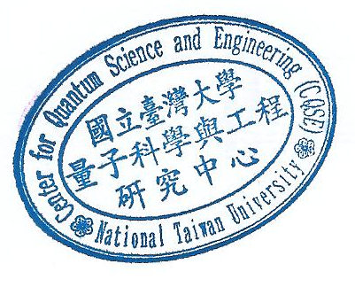
- APS Outstanding Referee 2023
- John Bardeen Award, 2004
- Harry G. Drickamer Research Fellowship, 2003
- Mavis Memorial Fund Scholarship Award, 2002
- Inducted to the Honor Society of Phi Kappa Phi 2002
- The Ministry of Education Graduate Fellowship, Taiwan, 1994 – 1996
- Scholarship for Gifted Senior High School Students Studying Mathematics and Natural Sciences (Ministry of Education, Taiwan), 1990 - 1994

