Joint CQSE & NCTS Special Seminar

2023
Aug. 07, Monday

TIME Aug. 07, 2023, 14:30~15:30pm
TITLE Many-Photon Quantum Systems -Photonic dimers as a new resource for quantum optical science and technology
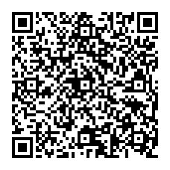
SPEAKER Prof. Jung-Tsung Shen (Das Family Career Development Distinguished Associate Professor of Electrical & Systems Engineering and Physics at Washington University in St. Louis)
PLACE NCTS Physics Lecture Hall, 4F, Chee-Chun Leung Cosmology Hall, NTU
ONLINE https://nationaltaiwanuniversity-zbn.my.webex.com/

Abstract:
Quantum properties of light have been shown to be critical to enabling applications such as secure communication, precision measurement, sensing, and computation, with potentially greater performance than that of existing technologies. Nonetheless, individual photons do not interact and the lack of quantum optical nonlinearity presents a major hurdle for several long-standing challenges in these fields. I will present an unusual quantum photonic state -- the photonic dimer -- which is a two-photon bound state and manifests the most fundamental quantum optical nonlinearity. I will discuss situations where the photonic dimers make a meaningful impact: In quantum information science, a long-sought deterministic, high-fidelity two-bit photonic quantum logic gate; and in quantum biological sensing, a quantum multi-photon excitation microscopy that enables deep-tissue optical imaging at centimeter-scales. Furthermore, I will explore the systems of an ensemble of photonic dimers, and discuss a possible realization ofa photonic-dimer laser -- a new type of quantum photonic light source outputting a coherent state of dimers. Possible photonic phase transitions in a many-photon system and the formation of quantum photonic fluid are also speculated.

Biography Brief:
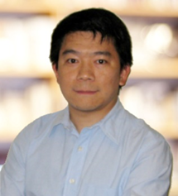
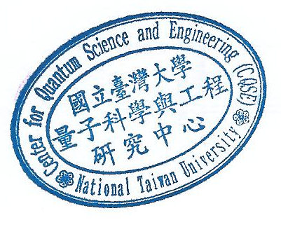
Jung-Tsung Shen is the Das Family Career Development Distinguished Associate Professor of Electrical & Systems Engineering and Physics at Washington University in St. Louis, where he directs the Quantum Nanophotonics Group. He received a Ph.D. in Physics from MIT, and was a postdoctoral researcher at the Electrical Engineering Department and the Ginzton Lab at Stanford. He aims to apply physical principles to gain deep insights into engineering problems. In addition to quantum nanophotonics, his group also researches engineered optical materials. In the field of metamaterial, he pioneered the mechanisms for the extraordinary enhancement of refractive index and optical nonlinearity and the operation of an ultrafast optical switch. Shen is the recipient of NSF CAREER Award, NSF Quantum RAISE Award, Chan Zuckerberg Deep Tissue Imaging Award, Bell Labs Graduate Scholarship, and Wash U Entrepreneur Award.

