Joint CQSE & NCTS Special Seminar

2023
Aug. 18, Friday

TIME Aug. 18, 2023, 2:30~3:30pm
TITLE Monte Carlo Quantum Algorithms
SPEAKER Mr. Chi-Fang Chen (California Institute of Technology)
PLACE NCTS Physics Lecture Hall, 4F, Chee-Chun Leung Cosmology Hall, NTU
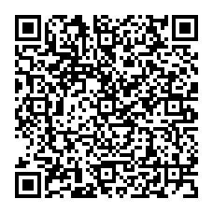
ONLINE https://nationaltaiwanuniversity-zbn.my.webex.com/

Abstract:
Classical Monte Carlo sampling has been fundamental in computational science. This talk presents the missing quantum counterpart: quantum algorithms for preparing quantum Gibbs states. This algorithm is the key to simulating low-temperature physics, which is the first anticipated application of future quantum computers.

Biography Brief:
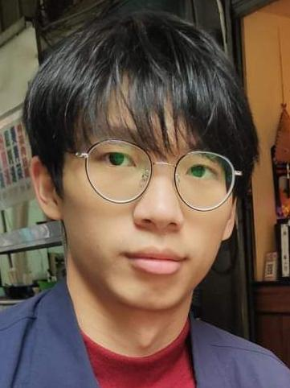
I am Chi-Fang Chen (陳麒⽅), a physics Phd Student at California Institute of Technology advised by Fernando G.S.L Brandao. I work on technical theoretical problems that have a broad practical impact, such as finding quantum computational advantage. Topics include quantum dynamic bounds, random matrix theory, thermodynamics, and quantum simulation.
