Joint CQSE & NCTS Seminar

2023
Sep. 15, Friday

TIME Sep. 15, 2023, 2:30~3:30pm
TITLE Probing 2D material's properties with superconducting quantum circuits coupled to 2D and 3D cavities
SPEAKER Assistant prof. Kuei-Lin Chiu (National Sun Yat-sen University)
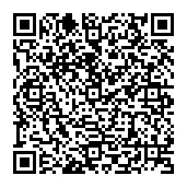
PLACE Rm104, Chin-Pao Yang Lecture Hall, CCMS & New Physics Building, NTU
ONLINE https://nationaltaiwanuniversity-zbn.my.webex.com/

Abstract:
Integrating 2D materials (such as graphene) with superconducting quantum circuits is an emerging topic in searching of new types of quantum computing devices owing to its superb conductivity and 2D gateable nature. Several key observations, such as gate-tunable qubit energy, Rabi oscillation and qubit relaxation time T1 (dephasing time T2∗) at the scale of 36 ns (51 ns), have been reported [1]. Topological materials, for their topologically protected surface and edge states which can serve as a robust channel to carry supercurrent, are also promising candidates for use in 2D materials-based quantum computing devices [2-3]. In addition, the S-T-S junction (S is superconductor and T is topological material) naturally provides a platform to explore the physics associated with Majorana bound states (MBS). In the first part of this talk, I will review this field and introduce some of such quantum circuits integrated with 2D cavities in our lab [4]. On the other hand, 3D cavity-based superconducting qubits have the advantages of allowing DC transport measurements on their composing Josephson junctions. In the second part of this talk, I will introduce our recent works on characterizing flux-tunable graphene quantum circuits residing in a copper 3D cavity.

[1] Joel I-Jan Wang, Daniel Rodan-Legrain, Landry Bretheau, Daniel L. Campbell, Bharath Kannan, David Kim, Morten
Kjaergaard, Philip Krantz, Gabriel O. Samach, Fei Yan, Jonilyn L. Yoder, Kenji Watanabe, Takashi Taniguchi, Terry P.
Orlando, Simon Gustavsson, Pablo Jarillo-Herrero & William D. Oliver, Nat. Nanotechnology, 14, 120 (2019)
[2] Wei-Chen Chien, Shun-Jhou Jhan, Kuei-Lin Chiu, Yu-xi Liu, Eric Kao, Ching-Ray Chang, Journal of Electronic
Materials, 49, 6844–6858 (2020)
[3] Kuei-Lin Chiu*, Yang Xu, Physics Reports 669, 1-42 (2017)
[4] Kuei-Lin Chiu*, D. G. Qian, J. W. Qiu, W. Y. Liu, D. Tan, V. Mosallanejad, S. Liu, Z. T. Zhang, Y. Zhao, D. P.
Yu, Nano Letters, 20, 12, 8469–8475 (2020)

Biography Brief:
Kuei-Lin Chiu is currently an Assistant Professor in the Department of Physics, National Sun Yat-sen University, Taiwan. Prior to this, he was an Associate Research fellow (faculty) in the Key laboratory of Quantum information, University of Science and Technology of China (USTC) and a post-doc at the Department of Physics at MIT (2015-2017). He obtained his PhD from the Cavendish Laboratory in Cambridge University where he worked on quantum transport in 2D material-based quantum dots involving using microwave to control single electrons. He received his BSc degree in applied physics from National Chia-Yi University (2000-2004) and his MSc degree in physics from National Chiao-Tung University (2004-2006). His current research focuses on superconducting quantum computing and topological materials. In particular, he demonstrated a flux-tunable superconducting quantum circuit consisting of Weyl semimetal MoTe2, with an intention to probe the topological properties of materials using superconducting qubit measurement techniques. This research is highlighted in the University news of NSYSU (Chinese: https://news.nsysu.edu.tw/p/406-1120-249261,r3979.php?Lang=zh-tw&fbclid=IwAR09pSyC-flYOvboYUHYidEqGgN5MaMnTjPEAisnLVcxBmjy7YcyA1ZDIIU English: https://www.nsysu.edu.tw/p/406-1000-249576,r3244.php?Lang=en).

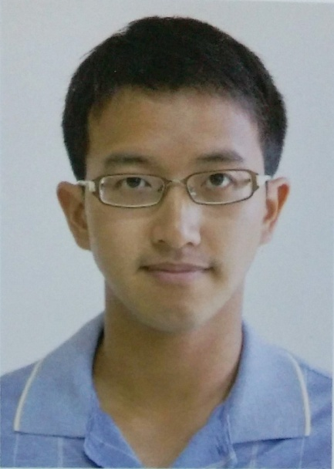
Assist Prof. Kuei-Lin Chiu
Kuei-Lin Chiu

klc@mail.nsysu.edu.tw,
eins0728@gmail.com

Quantum Circuits Laboratory
Faculty page
Linkedin page

07-5252000-3725
office:PH6004

Research areas：Quantum computing, Quantum transport, Superconducting qubits, 2D material devices

Education:
●Ph.D., Department of Physics, University of Cambridge (2008 - 2012)
●M.S., Institute of Physics, National Chiao-Tung University (2004 - 2006)
●B.S., Department of Applied Physics, National Chia-Yi University(2000-2004)
經歷
Major Experience:
● Assistant Professor, National Sun Yat-sen University, Taiwan (2019/08 - Present)
● Consultant, Quantum Computing Research Center in Hon Hai (Foxconn) Research Institute, Taiwan (2021/07 – present)
● Associate Research Fellow (faculty), Key Lab of Quantum Information, University of Science and Technology of China, China (2017/07 – 2018/08)
● Postdoctoral Fellow, Department of Physics, Massachusetts Institute of Technology, USA (2015/01 – 2017/05)
● Research Associate, Cambridge Graphene Centre, Department of Engineering, University of Cambridge, UK (2013/03 – 2014/10)

Services:
● Guest editor, SPIN (ISSN (print): 2010-3247 | ISSN (online): 2010-3255), special issue: “Recent Progresses of Taiwan Quantum Technologies” (2023/04 - 2023/09)
● Local Organizing Committee, The international conference on Quantum Information Processing (QIP) 2024 Taipei: https://qip2024.tw/site/mypage.aspx?pid=239&lang=en&sid=1522 (2023/05 - 2024/01)

Research Interests
● 2D material nanostructures
● 2D material based Josephson junctions
● Superconducting quantum circuits
● Quantum computing devices
