Joint CQSE & NCTS Seminar

2023
Oct. 06, Friday

TIME Oct. 06, 2023, 2:30~3:30pm
TITLE Privacy-Enhancing Technologies with Quantum Safe Future
SPEAKER Dr. Yao-Tung Tsou (President and Chief Technology Officer, DeCloak Intelligences Co. )
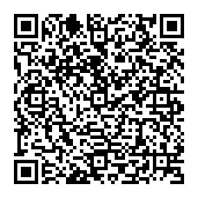
PLACE Rm104, Chin-Pao Yang Lecture Hall, CCMS & New Physics Building, NTU
ONLINE https://nationaltaiwanuniversity-zbn.my.webex.com/

Abstract:
In today's society, the importance of data protection and privacy preservation has never been more critical. This presentation delves into how we can employ various privacy-enhancing technologies to safeguard sensitive information, with a particular focus on achieving quantum-safe security. To begin, we'll explore the significance of data leaks and privacy protection, emphasizing the need for robust security measures to counter potential quantum computing threats. We will then introduce several privacy-enhancing data protection technologies that not only effectively protect privacy but also ensure quantum security. Key technologies under scrutiny include Differential Privacy and Homomorphic Encryption. We will elucidate the workings of these technologies and how they can be harnessed to achieve quantum-safe data protection goals. Differential Privacy makes data leaks exceedingly challenging, while Homomorphic Encryption enables computations to be performed while data remains encrypted, preserving data privacy. Lastly, we will provide real-world examples to showcase the practical applications of privacy computing. These case studies will highlight how privacy-enhancing technologies assist businesses and organizations in safeguarding the privacy of their customers and users while preparing for future quantum computing challenges. Through this presentation, we will gain a deeper understanding of the importance of privacy protection and how privacy-enhancing technologies can ensure a quantum-safe future.

Biography Brief:
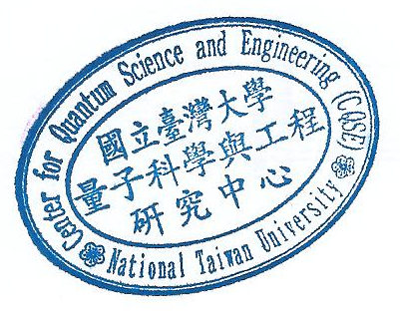
Dr. YT Tsou currently serve as the President and Co-founder of DeCloak Intelligences Co., leading innovations in privacy computing technologies with AI/ML model to protect data security and privacy. My journey includes roles such as an Associate Professor at Feng Chia University, Executive Director at Taiwan Artificial Intelligence and Blockchain Applications Association, Advisor at Swiss Innovation Valley, Visiting Scholar at the Central Research Institute of Information Innovation and Technology, Guest Editor at MDPI Electronics Journal, and positions as Assistant Professor, Postdoctoral Researcher, and Technical Advisor. My early career involved research roles at the Central Research Institute of Information Innovation and Technology and the Institute of Information Science at Academia Sinica. I remain dedicated to advancing technology and fostering innovation in cybersecurity and data privacy protection.

