Joint CQSE & NCTS Seminar

2023
Oct. 13, Friday

TIME Oct. 13, 2023, 2:30~3:30pm
TITLE Application of quantum computing in chemical industry
SPEAKER Dr. Tsung-Hui Li (Senior Engineer, Formosa Plastics Corporation )

PLACE Rm104, Chin-Pao Yang Lecture Hall, CCMS & New Physics Building, NTU
ONLINE https://nationaltaiwanuniversity-zbn.my.webex.com/

Abstract:
Nowadays, more and more world-class companies aware the potential of quantum computing, they start to cooperate with top universities and quantum computing software companies to develop and design computing platform hybrid by CPU, GPU and QPU systems. As the number of qubits increasing, algorithms designed by collocation of classical and quantum system will surely be able to take advantage in solving exponential problems. Quantum-related research needs to integrate talents from interdisciplinarity (such as physics, mathematics, chemistry, and engineering, etc.). The government, academia, and enterprises must prioritize facing the shortage of talent and cultivate new talents in fields of science, technology, engineering, and mathematics. And need to implement measure to recruit and retain the suitable talents.
With quantum-inspired computing (digital annealing) and QUBO model, the time cost of screening decreases to 1/10 ~1/15. Significantly benefit materials development and functional molecules selections. In summary, interdisciplinarity is the key of quantum computing applications, which makes team members share core concepts of the quantum research.
Furthermore, proceeding knowledge of team and raising new talents and eventually, flourishing ideas of innovation will emerge and put into practice.

Biography Brief:
1. B.S. in Chemistry, Tunghai University, 2001.
2. Master in Chemistry and Biochemistry, National Chung Cheng University, 2003.
3. Ph.D. in Chemistry and Biochemistry, National Chung Cheng University, 2008.
4. Postdoc Researcher, National Taiwan University, 2008-2009.
5. Senior engineer, China Petrochemical Development Corporation, 2009-2014.
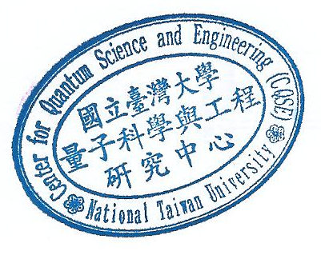
6. Senior engineer, Formosa Plastics Corporation, 2016- until now.

