Joint CQSE & NCTS Seminar

2023
Nov. 17, Friday

TIME Nov. 17, 2023, 14:30~15:30 pm
TITLE Quantum sensing with solid-state quantum electronics
SPEAKER Prof. Tse-Ming Chen (Department of Physics and Director of the Center for Quantum Frontiers of Research & Technology (QFort), National Cheng Kung University)
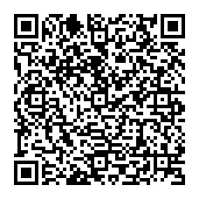
PLACE Rm104, Chin-Pao Yang Lecture Hall, CCMS & New Physics Building, NTU
ONLINE https://nationaltaiwanuniversity-zbn.my.webex.com/

Abstract:
Quantum sensing leverages properties like interference, superposition, and entanglement for superior precision and stability in measurements beyond traditional methods. Prior research has primarily centered on cold atoms and quantum optics. However, with rapid advances in nanoscience and solid-state quantum computing, the realization of innovative quantum sensing using superconducting and semiconductor quantum electronics has emerged as a new potential direction. In this talk, I will present some of our recent advances in quantum sensing with semiconductor quantum dots and our progress with superconducting qubits, along with an outlook on possible future directions in this field of quantum sensing.
Biography Brief:
Tse-Ming Chen is a Professor in Physics and also serves as the Director of the Center for Quantum Frontiers of Research & Technology (QFort) at National Cheng Kung University. He received his BS and MS degrees from National Taiwan University in Taiwan and PhD from Cambridge University in the UK, all in physics. Tse-Ming has over 20 years of experience in low-temperature condensed matter physics experiments, with expertise in the design, nanofabrication, and electrical transport measurements of quantum devices and nanoarchitectures based on diverse materials such as semiconductors, superconductors, 2D materials, topological materials, and complex oxides. His research interests span a wide range of topics, including mesoscopic physics, quantum electronics, spintronics, and the engineering of quantum systems.
