Joint CQSE & NCTS Special Seminar

2023
Nov. 30, Thursday

TIME Nov. 30, 2023, 10:30~12:00 pm
TITLE Implementation of Quantum Gates on IBM-Quantum : pulse-level control of superconducting qubits
SPEAKER Prof. Michihiko Sugawara (Project Associate Professor, Quantum Computing Center, Keio University)
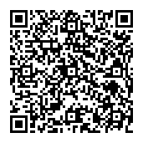
PLACE NCTS Physics Lecture Hall, 4F, Chee-Chun Leung Cosmology Hall, NTU
ONLINE https://nationaltaiwanuniversity-zbn.my.webex.com/

Abstract:
The coherence time of transmon-based superconducting qubits has now surpassed 100 micro seconds, and the error rate for single-qubit SU(2) gates implemented with well-calibrated π/2 and π pulses has reached 0.0001. However, the error rate of 2-qubit gates remains around 30 times larger, compared to that of single-qubit gates. Thus, improving the fidelity of 2-qubit gates has become an urgent priority for enhancing the capabilities of superconducting quantum devices in the NISQ era.
This presentation introduces the implementation techniques of 1 and 2-qubit basis gates employed by IBM Quantum's quantum devices, such as virtual Z gate and echoed CX gate. Additionally, we present a unitary process tomography (UPT)-based implementation of pulse-efficient SU(4) gates on cross resonance (CR)-based superconducting quantum devices. We successfully implemented a continuous RZZ gate as a 2-qubit basis, as an echo-free pulse schedule on the IBM Quantum device (ibm kawasaki) and evaluated the average fidelity and gate time of various SU(4) gates to confirm the advantages of the present method.
Biography Brief:

EDUCATION
B. Sc. 1988, Department of Chemistry, Faculty of Science, Tohoku University (Sendai, Japan)
M. Sc. 1990, Department of Chemistry, Faculty of Science, Tohoku University (Sendai, Japan)
Ph. D. 1993, Department of Chemistry, Faculty of Science, Tohoku University (Sendai, Japan)

WORKING EXPERIENCE
JSPS Postdoctoral Fellow, Tohoku University (Sendai, Japan), 1992-1994.
Postdoctoral Fellow, Arizona State University (Tempe, USA), June 1994 - October 1994
Postdoctoral Fellow, Institute of Atomic and Molecular Sciences, Academia Sinica (Taipei, TAIWAN), November 1994 - March 1995
Department of Chemistry, Faculty of Science and Technology, Keio University (Yokohama, Japan), Research Assistant 1995 - 2002.
Department of Chemistry, Faculty of Science and Technology, Keio University (Yokohama, Japan), Assistant Professor 2002 - 2018.
Keio Quantum Computing Center, Faculty of Science and Technology, Keio University (Yokohama, Japan), Project Associate Professor 2019 - present.

RESEARCH INTEREST / EXPERIENCE
Microwave pulse-designing for gate implementation on IBM Quantum devices.
VQE / QAOA analysis using IBM Quantum devices.
Theoretical analysis on coherent control of chemical reaction by optimal laser fields.
Numerical solution of vibrational Schrödinger equation by intelligent methods (neural network and genetic algorithm), finite-element method.
Theoretical wave packet study on pump-probe stimulated emission signals and photo-induced chemical reactions.
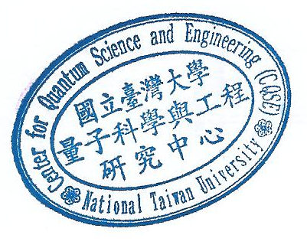
Theoretical studies on ultra-fast dynamics in condensed phase by the density matrix method.

