Joint CQSE & NCTS Seminar

2023
Dec. 01, Friday

TIME Dec. 01, 2023, 14:30~15:30 pm
TITLE Physics-inspired Optimization in the QUBO Framework: Key Concepts and Approaches
SPEAKER Dr. Lien-Po Yu (Research fellow at the Institute for Information Industry)

PLACE Rm104, Chin-Pao Yang Lecture Hall, CCMS & New Physics Building, NTU
ONLINE https://nationaltaiwanuniversity-zbn.my.webex.com/

Abstract:
Quantum computing promises to have a tremendous advantage over its classical counterpart for solving computationally hard problems, yet remains in a relatively early stage for practical applications owing to the physical and engineering challenges to today’s quantum computers. The approach to addressing instead the special purposes, like combinatorial optimization, of quantum computers by exploiting the special-purpose physics- or quantum-inspired computers is emerging as a novel practical alternative to its quantum counterpart in tackling hard problems in the realm of high-performance computing. Inspired by physics, the Ising machine - a type of special-purpose computer that implements or emulates physics or quantum effects of the Ising model to speed up finding solutions to optimization problems - has recently become an active research area in the field of combinatorial optimization. This talk is to address the key enabling software and hardware technology underlying physics-inspired optimization using Ising machines in the unified quadratic unconstrained binary optimization (QUBO) framework, and with an aim to shed some light on the challenges and opportunities associated with the ever-growing landscape of this novel high-performance computing.
Biography Brief:
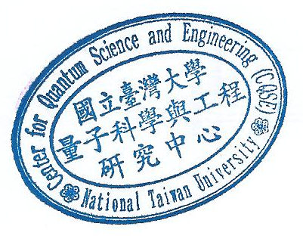
于濂波 Lien-Po Yu, Ph.D. in Electrical Engineering (EE), National Taiwan University, Taiwan, R.O.C., M.S. in Applied Mathematics, National Tsing Hua University, Taiwan, R.O.C., B.S. in Mathematics, National Tsing Hua University, Taiwan, R.O.C. Dr. Lien-Po Yu is currently a research fellow at the Institute for Information Industry (III, 資訊工業策進會) where he has assumed various supervisory roles and responsibilities for a number of institute-industry collaboration and government-commissioned projects on information and communication technology (ICT). Prior to joining the III, Dr. Yu has held several managerial and technical leadership roles at the Hon Hai Precision Industry Co., Ltd., (a.k.a. Foxconn Technology Group, 鴻海科技集團) and the Chung-Shan Institute of Science and Technology (CSIST, 中山科學研究院) respectively where he has been devoted to the research and development of consumer electronics and military avionics systems, and also engaged in exploring and advancing the multidisciplinary collaboration with international partners from EU and US. His current research interests include quantum computing, quantum-inspired computing, system and software engineering, etc.

