Joint CQSE & NCTS Special Seminar

2024
Jan. 04, Thursday

TIME Jan. 04, 2024, 14:30~15:30 pm
TITLE Building Quantum Error Correcting Codes with Tensor Networks and Machine Learning
SPEAKER Dr. Vincent P. Su (PhD Candidate in Physics at UC Berkeley)
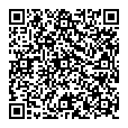
PLACE NCTS Physics Lecture Hall, 4F, Chee-Chun Leung Cosmology Hall, NTU
ONLINE https://nationaltaiwanuniversity-zbn.my.webex.com/

Abstract:
Quantum error correction design is a difficult but important problem on the road to fault tolerance. In this talk, I will review one way to build larger quantum error correcting codes from smaller ones. By treating the individual encoding unitaries as tensors, small QECCs can be stitched together producing rich emergent behavior. For example, the surface code can be built from many identical copies of a simple 4 qubit code. By treating code building as a game, we are able to use machine learning methods to build novel codes that i) saturate bounds on distance for CSS codes and ii) outperform surface code variants for ~20 qubits at protecting logical information from biased Pauli noise. Based on https://arxiv.org/abs/2305.06378
Biography Brief:
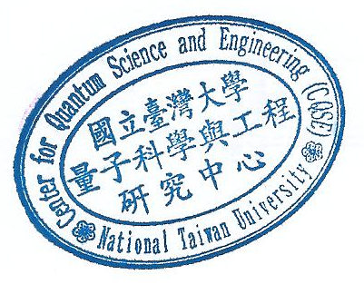
Vincent Su is currently wrapping up his PhD in Physics at UC Berkeley under the supervision of Prof. Raphael Bousso. His interests include quantum error correction, quantum information and machine learning. Previously, he completed his B.S. in Physics and M.S. in Computer Science at Stanford.

