Joint CQSE & NCTS Seminar

2024
Mar. 08, Friday

TIME Mar. 08, 2024, 14:30~15:30 pm
TITLE Proposal of 3D qubit system

SPEAKER Prof. Tetsufumi Tanamoto (Graduate School of Science & Engineering, Teikyo University)
ONLINE https://nationaltaiwanuniversity-zbn.my.webex.com/

Abstract:
Spin qubit systems are one of the promising candidates for quantum computing. The quantum dot (QD) arrays are intensively investigated by many researchers. Because the energy-difference between the up-spin and down-spin states is very small, the detection of the qubit state is of prime importance in this field. Moreover, many wires are required to control qubit systems. Therefore, the integration of qubits and wires is also an important issue. Here, the measurement process of QD arrays is theoretically investigated using resonant tunneling, controlled by a conventional transistor. It is shown that the number of possible measurements during coherence time can exceed a hundred under the backaction of the measurements owing to the nonlinear characteristics of resonant tunneling[1].
The possible 3D qubit structure using the state-of-the-art advanced transistor (nanosheet) is proposed, aiming at the surface code in Silicon. A couple of fabrication schemes are also proposed for the experimentalists using academic facilities.
[1] T. Tanamoto and K. Ono, J. Appl. Phys. 134, 214402 (2023).https://doi.org/10.1063/5.0174588
Biography Brief:
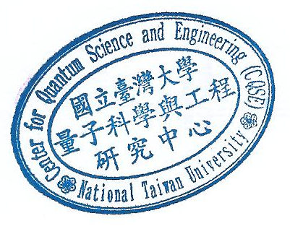
Tetsufumi Tanamoto received the B.S. degree in Physics from Kyoto University, Kyoto, Japan, in 1988. He received the M.S. and Ph.D. degree from The University of Tokyo, Tokyo, Japan, in 1990, and 1995, respectively. In 1991, he was with the R&D Center, Toshiba Corporation, Kawasaki, Japan. Since 2018, he has been the professor of graduate School of Science & Engineering, Teikyo University, Japan. His recent interests include the science and the technologies of quantum computing and CMOS circuits.

