Joint CQSE & NCTS Seminar

2024
Mar. 22, Friday

TIME Mar. 22, 2024, 14:30~15:30 pm
TITLE Computational Modeling of Nanoelectronics and Emerging Materials
SPEAKER Research Fellow, Chao-Cheng Kaun (Research Center for Applied Sciences, Academia Sinica)

PLACE NCTS Physics Lecture Hall, 4F, Chee-Chun Leung Cosmology Hall, NTU
ONLINE https://nationaltaiwanuniversity-zbn.my.webex.com/

Abstract:
Using first-principles calculations based on density functional theory, we investigate electronic transport through carbon-, silicon- and transition metal dichalcogenide (TMD)-based nanojunctions for nanoelectronic applications. Effects of doping, contacting and quantum interfering are addressed. We also study the efficiencies of CO2 photoconversion and hydrogen evolution reaction in TMD and oxides for sustainable-energy applications. Effects of nanoparticle-adsorbing and material-configuring are highlighted. Moreover, we explore the plasmonic properties of complex transition metal nitrides for photonic applications.
Biography:
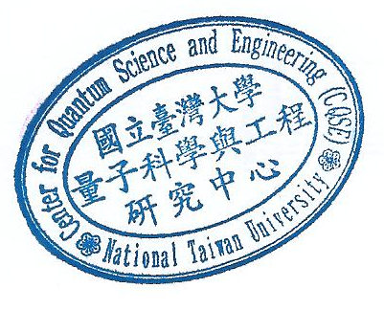
Chao-Cheng Kaun received the M.Sc. degree in Physics from National Taiwan University, in 1995 and the Ph.D. degree in Physics from McGill University, Canada, in 2004. Then he joined the Department of Chemistry, Northwestern University, USA, as a Postdoctoral Fellow. Since August 2006, he has been with the Research Center for Applied Sciences, Academia Sinica, Taiwan, where he was an Assistant Research Fellow, became an Associate Research Fellow and a Research Fellow in 2013 and 2017, respectively. His current research interests include computational nanoelectronics, quantum transport in mesoscopic systems, and emerging materials for sustainable energy.
https://www.rcas.sinica.edu.tw/RCAS-ch/pi_web/kauncc.php#

