Joint CQSE & NCTS Seminar

2024
Apr. 19, Friday

TIME Apr. 19, 2024, 15:30~16:30 pm
TITLE Building Spin-Orbit Qubits with Holes in Silicon and Germanium
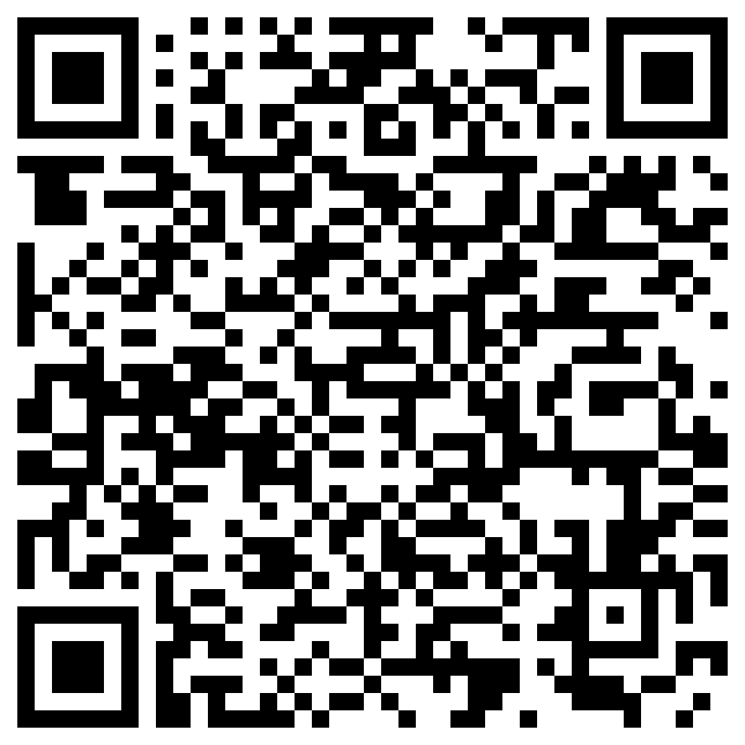
SPEAKER Prof. Dominik Zumbühl (Department of Physics, University of Basel and Director of NCCR SPIN)
PLACE NCTS Physics Lecture Hall, 4F, Chee-Chun Leung Cosmology Hall, NTU
ONLINE https://nationaltaiwanuniversity-zbn.my.webex.com/

Abstract:
Quantum computers hold the potential to solve key tasks exponentially faster than classical computers, giving rise to a new quantum era. Classical transistor scaling achieved the integration of billions of transistors on-chip reaching sizes so small that a single electron or hole can be trapped and held in place. The magnetic moment of such a trapped charge – the spin – is a prime contender for building scalable quantum bits out of classical transistors, thus making semiconductor spins a leading candidate for full-scale quantum computing.

The spin-orbit interaction (SOI) is at the heart of key phenomena in condensed matter physics. It arises from the relativistic physics conveniently creating magnetic out of electric fields, working very efficiently for holes in semiconductors. This makes possible all-electrical coherent spin manipulation without requiring micromagnets, thus reducing the qubit footprint and improving scaling. Yet the SOI, similar to micromagnets, also opens the door for charge noise to cause spin dephasing, thus posing a fundamental challenge for spin qubits.

In this talk, I will present recent progress on building spin-orbit qubits with holes in Ge/Si core/shell nanowires and Si fin FETs. Highlights include ultrafast qubits, taking only 1 ns to coherently rotate a spin from pointing up to down; operation of spin qubits up to 5 K, where vast cooling power becomes available, making possible integration of the classical control electronics; operation of a 2-qubit gate with highly anisotropic exchange, allowing for high fidelity gate operation while operating at high speeds; and finally a sweet spot combining both maximal coherence and maximal speed, thus opening new avenues for ultrafast and highly coherent spin-orbit qubits.

These experiments are supported by laboratory instruments developed by our spin-off Basel Precision Instruments GmbH, including low-noise amplifiers, high-resolution voltage sources and cryogenic microwave filters and thermalizers.

This work was supported by the NCCR SPIN, the Swiss National quantum computation program of the Swiss NSF, the Swiss Nanoscience Institute (SNI), the Georg H. Endress Foundation, and the EU H2020 European Microkelvin Platform EMP, TOPSQUAD and QLSI programs.

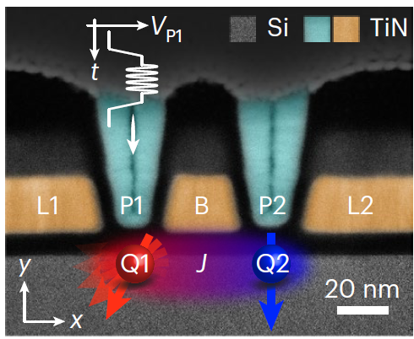
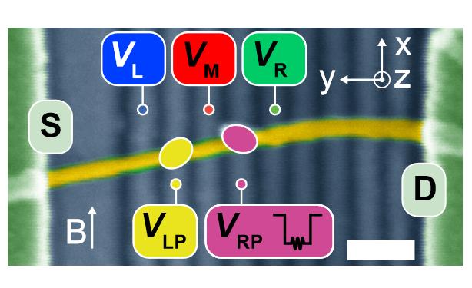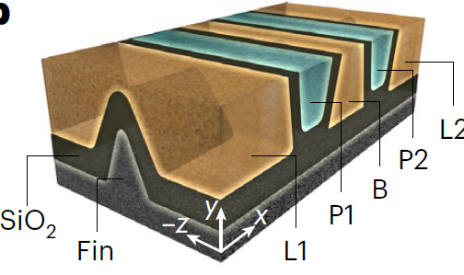

Biography:
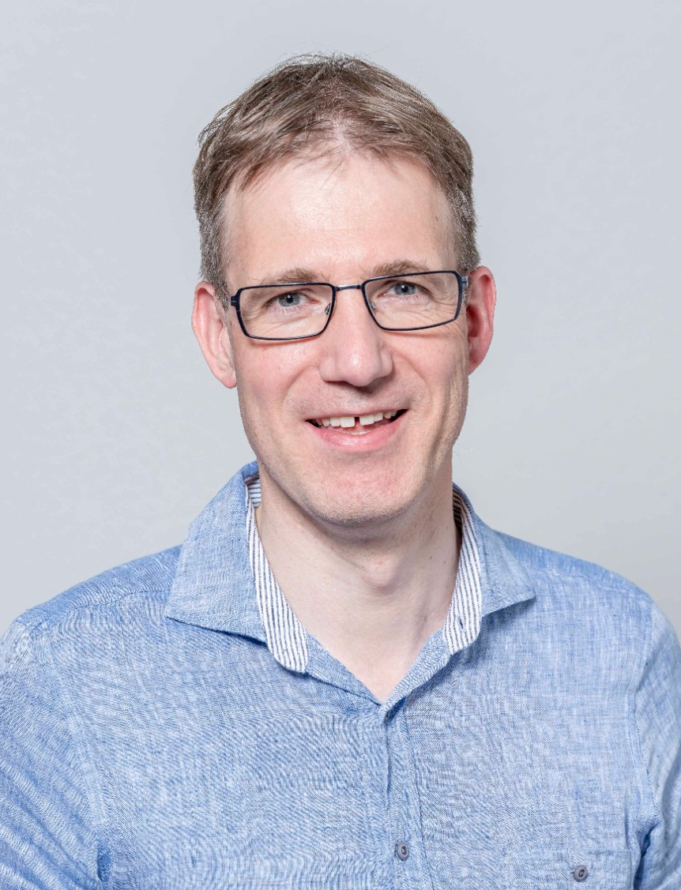
Dominik received his PhD at Harvard University in 2004 on quantum coherence and spin in semi-conductor quantum dots after receiving a physics diploma from ETH Zürich in 1998 and a MSc in 2000 from Stanford University. After a 2-year postdoc at MIT, Dominik started his own group in 2006 at the University of Basel where he has been working since. In 2008, he received a starting grant in the first ERC call. He was promoted to associate professor in 2012 and to full professor in 2023. He served as Department Chair from 2015-2019 and since 2021, he is the director of the NCCR SPIN, the Swiss National Program on Quantum Computing with Si and Ge spins. In 2023, Dominik was elected as a fellow of the APS.
