Joint CQSE & NCTS Seminar

2024
May 10, Friday

TIME May 10, 2024, 14:30~15:30 pm
TITLE Electromagnetic field- and surface acoustic wave-induced decoherence in a ballistic quantum interferometer
SPEAKER Prof. Jeng-Chung Chen (NTHU)
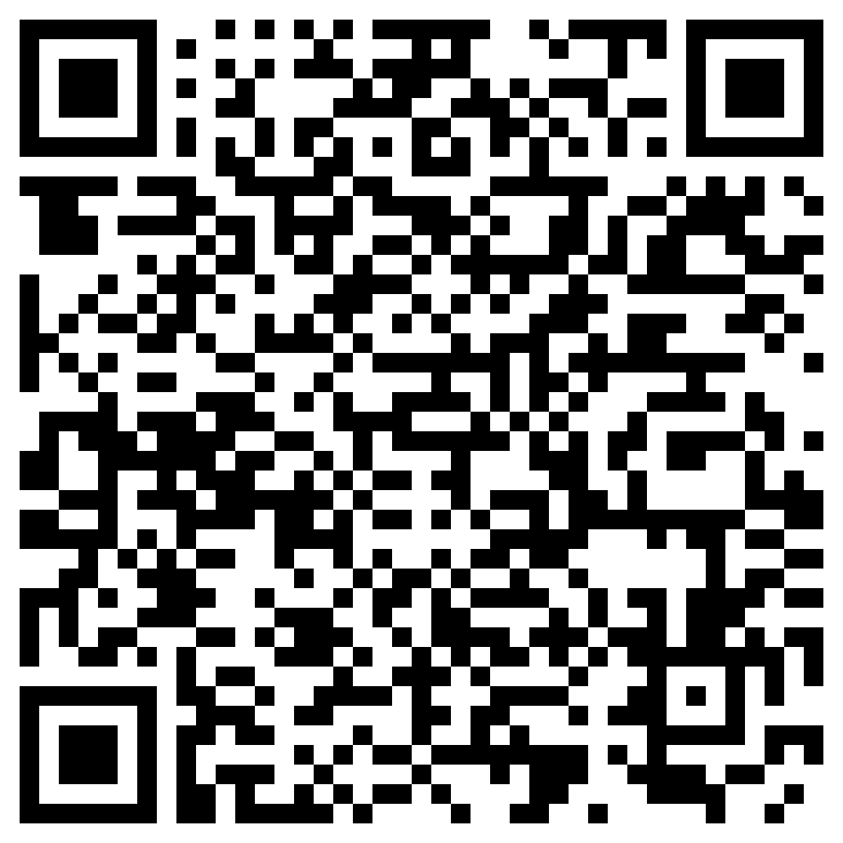
PLACE NCTS Physics Lecture Hall, 4F, Chee-Chun Leung Cosmology Hall, NTU
ONLINE https://nationaltaiwanuniversity-zbn.my.webex.com/

Abstract:
We report on the studies of decoherence processes of a ballistic quantum interferometer in the presence of a radio-frequency (RF) electromagnetic (EM) field and surface acoustic wave (SAW). The device comprises an Aharonov-Bohm (AB) ring sandwiched between two interdigital transducers (IDTs), where the AB ring serves as a phase sensor and the IDTs function as a controlled source of environmental noise. By employing the IDTs with RF signal to launch a SAW train through the ring, we extract the decoherence rate, associated with the dephasing process induced by the thermal fluctuations of the RF-EM field, SAW, and the acoustoelectric current, from the AB oscillation amplitude. Consequently, we find the RF-EM field-induced phase-breaking effects without thermal heating and, more importantly, identify the optimal conditions for operating SAW to minimize dephasing. The underlying mechanism responsible for the decoherence is attributed to the enhancement of charge-charge interactions in the presence of the RF-EM field and SAW. Our findings have significant implications for the development of flying-qubit techniques utilizing surface acoustic effects, offering new avenues for solid-state quantum information processing and quantum computing applications.
Biography:
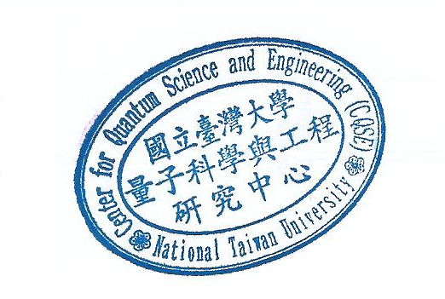
https://drive.google.com/file/d/1vaJBfNXRGzczttwkqUq3fwVp99Zc1eRR/view?usp=sharing

