Joint CQSE & NCTS Seminar

2025
March. 14, Friday

Time: March. 14, 14:30 ~ 15:30
Title: Quantum Walk Finds a Way for GKP!!
Speaker: 吳欣澤副教授 (Department of Physics, National Chung Cheng University)
Place: NCTS Physics Lecture Hall, 4F, Chee-Chun Leung Cosmology Hall, NTU
Online Link: https://nationaltaiwanuniversity-zbh.my.webex.com/nationaltaiwanuniversity-zbh.my/j.php?MTID=m2a963d31adcf732fcddcf95022ff7210

Abstract:
In this talk, I will explain a theoretical framework for encoding a quantum bit (qubit) into a continuous-variable quantum mode (often referred to as a “bosonic mode”) through quantum walks, which I had developed along with my colleagues a few years ago. Starting with a squeezed-vacuum state of a bosonic mode, I will show that quantum walk of the state in phase space can generate variants of codestates originally put forward by Gottesman, Kitaev, and Preskill (GKP) [Phys. Rev. A 64, 012310 (2001)]. In particular, with a coin-toss operation that projects the quantum coin onto the diagonal coin-state, I will show that the resulting “dissipative” quantum walk provide pathways to generating approximate GKP qubits. Besides its possible implementation through superconducting circuit systems, in particular, I will present a linear-optical approach to realizing this encoding scheme that we have recently discovered.
Biography:

Shin-Tza Wu obtained his PhD from the University of Cambridge in 1999. After that,
he went on as postdocs first at the Department of Physics at National Tsing-Huan
University Hsinchu, and then at the Institute of Physics at Academia Sinica Taipei. In
2004, he joined the Department of Physics of National Chung Cheng University at
Chiayi. Dr Wu had worked previously on theories related to cavity quantum
electrodynamics, transports in superconducting junctions, and physics of ultracold
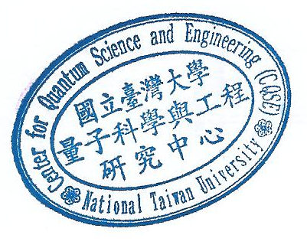
atoms. In recent years, he has focused mainly on problems related to quantum computing, in particular, concerning their possible physical realizations..

