Joint CQSE & NCTS Seminar

2025
April 18, Friday

Time: April 18, 14:30 ~ 15:30
Title: From AI to Quantum Computing
Speaker: Prof. Yuan-Hsiang Chang (Dept. of Information and Computer Engineering, Chung Yuan Christian University)
Place: NCTS Physics Lecture Hall, 4F, Chee-Chun Leung Cosmology Hall, NTU
Online Link: https://nationaltaiwanuniversity-zbh.my.webex.com/nationaltaiwanuniversity-zbh.my/j.php?MTID=m2a963d31adcf732fcddcf95022ff7210

Abstract:
This talk will briefly discuss recent developments of AI techniques and Quantum Computing (QC). We will discuss fundamental differences and challenges between classical and quantum computing. Further, potentials and advantages of QC for AI applications are presented with an attempt to trigger novel research idea.

Biography:

Yuan-Hsiang Chang, Ph.D.
Professor, Dept. of Information and Computer Engineering
CEO, Quantum Information Center
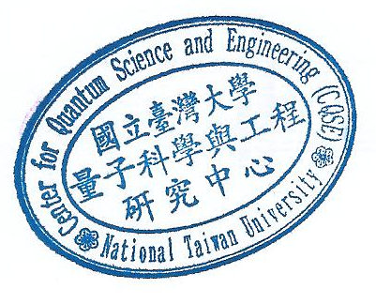
Taiwan

