Joint CQSE & NCTS Online Seminar

2021
Oct. 22, Friday

TIME Oct. 22, 2021, 2:30~3:30pm
TITLE Simulating Energy Transfer Dynamics of Photosynthetic Systems — From Master Equations to Quantum Computation
SPEAKER Prof. Yuan-Chung Cheng
Dept. of Chemistry, National Taiwan University
PLACE Rm104, Chin-Pao Yang Lecture Hall,
CCMS & New Physics Building, NTU

Abstract:

The ultrafast dynamics of light harvesting in natural photosynthetic systems enable
remarkable near-unity quantum efficiency in the light reactions of photosynthesis, yet, the full elucidation of the molecular mechanisms leading to such high quantum efficiency remains elusive. In this talk, I will present our theoretical investigations into excitation energy transfer (EET) in photosynthetic systems in two fundamentally different parts. In the Part One, I will provide a brief introduction on the fundamental theoretical background for the description of EET processes in photosynthetic systems and then illustrate a first-principle approach that combines quantum chemistry calculations and quantum master equation simulations to model light harvesting in the Photosystem II complex, which represents the state-of-the-art tool for simulating photosynthetic energy transfer dynamics on classical computers. In the Part Two, I will present our recent results in utilizing near-term quantum computer systems to simulating a simple energy transfer model problem. Quantum simulation of chemical systems represents the most promising quantum application to demonstrate quantum advantage on near-term noisy intermediate-scale quantum (NISQ) computers, and we have developed a novel scheme to utilize intrinsic gate errors of IBM-Q superconducting qubit devices to enable controllable simulation of excitation energy transfer dynamics without ancillary qubits or explicit bath engineering. By employing tailored decoherence- inducing gates, we demonstrate that quantum dissipative dynamics can be simulated efficiently across coherent-to-incoherent regimes with results comparable to those of the numerically-exact classical method. This work provides a new direction for quantum advantage in the NISQ era, and shows the possibility of turning NISQ devices into extremely useful and programmable platforms to study open quantum systems under complicated system-bath interactions. A comparison between Parts One and Two provides insightful aspects on the restrictions as well as potentials of quantum simulation for open quantum system dynamics, and hopefully, can assist in future employment of quantum computers to simulate dynamics in complexities beyond what nowadays classical computers can do for us.
Biography Brief:

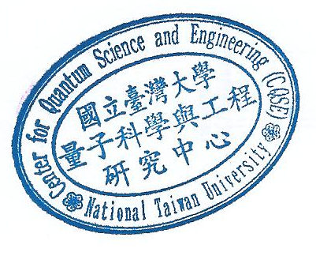
Dr. Yuan-Chung Cheng is currently a professor in the Department of Chemistry, National Taiwan University, Taiwan. His research interests are in the area of non-equilibrium statistical mechanics and quantum dynamics of condensed-phase molecular systems. Dynamics of photosynthetic light harvesting. Photon-induced chemical dynamics. Theories for ultrafast nonlinear spectroscopy. Theoretical multiscale modeling of organic optoelectronic nano-materials.

