Joint CQSE & NCTS Online Seminar

2021
Oct. 29, Friday

TIME Oct. 29, 2021, 2:30~3:30pm
TITLE Portfolio Optimization based on Novel Assessment Strategies and Quantum-inspired Search Algorithms
SPEAKER Prof. Shu-Yu Kuo
Dept. of Computer Science and Engineering, National Chung Hsing University
PLACE Rm104, Chin-Pao Yang Lecture Hall,
CCMS & New Physics Building, NTU

Abstract:

The task of optimizing the portfolio is to have a stable return and lower its overall risk. Selecting the best combination of stocks with low risk and high return simultaneously is a significant challenge for investors. Deciding which stocks should be invested in or not and finding the optimal combination of parameters for different technical indicators with targets and different investment situations are quite difficult in such a large solution space as well. In this talk, I will talk about our recent works on portfolio optimization based on novel assessment strategies. Experiments show many interesting and promising results by using quantum-inspired search algorithms.
Biography Brief:

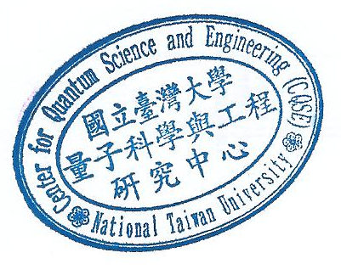
Shu-Yu Kuo received her B.S., M.S., and Ph.D. degree from the Department of Computer Science and Information Engineering, National Chi Nan University, Nantou, Taiwan. She was a Visiting Postdoctoral Research Associate with the Department of Electrical Engineering, Princeton University, Princeton, NJ, USA, in 2018 and 2019. Currently, she is an assistant professor with the Department of Computer Science and Engineering, National Chung Hsing University, Taichung, Taiwan. Her current research interests include quantum-inspired metaheuristic algorithms, financial technology, wireless sensor networks, and quantum cryptography.

