Joint CQSE & NCTS Seminar

2021
Nov. 26, Friday

TIME Nov. 26, 2021, 2:30~3:30pm
TITLE Introduction to Trapped Ion Quantum Computation
SPEAKER Associate Research Fellow, Ming-Shien Chang
Institute of Atomic and Molecular Sciences, Academia Sinica
PLACE Rm104, Chin-Pao Yang Lecture Hall,
CCMS & New Physics Building, NTU

Abstract:

The breathtaking development of quantum technologies since the late 90s of the 20th century has transformed our view of quantum phenomena from subjects for research to resources for applications. Among the proposed applications, quantum computation is considered the highest level of quantum technologies and has become a hot research subfield with explosive growth in the last five years. In this talk, I will briefly review the progress of quantum computation, particularly with an array of trapped and laser-cooled atomic ions. I will explain its working mechanism, current status, and future perspectives.
Biography Brief:

Education
B.S., 1995, National Taiwan University, Taiwan
M.S., 1997, National Taiwan University, Taiwan
Ph.D., 2006, Georgia Institute of Technology, USA

Experience
Postdoctoral Research Fellow, Physics Department and FOCUS Center, University of Michigan (2006–2007)
Postdoctoral Research Fellow, Physics Department and Joint Quantum Institute, University of Maryland
(2007–2009)
Assistant Research Fellow, IAMS, Academia Sinica (2009–2018)
Associate Research Fellow, IAMS, Academia Sinica (2018–)

Research Interests
Bose-Einstein Condensation, spinor condensates
Quantum computation/simulation with cold atoms
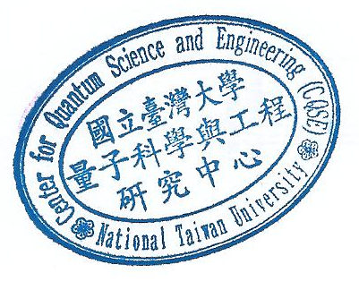
Sensing and quantum optics studies with nanodiamonds

