Joint CQSE & NCTS Seminar

2021
Dec. 03, Friday

TIME Dec. 03, 2021, 2:30~3:30pm
TITLE Quantum-inspired Computing for Combinatorial Optimization
SPEAKER Technical Director, Lien-Po, Yu
Institute for Information Industry
PLACE Rm104, Chin-Pao Yang Lecture Hall,
CCMS & New Physics Building, NTU

Abstract:

Quantum computing is promised to be one of the most transformative technologies in the post Moore’s Law era. Inspired by the principles of quantum mechanics, the approach to tackling the “special purposes of quantum computer (e.g., combinatorial optimization)” by exploiting the “special-purpose quantum/quantum-inspired computer (e.g. Ising machine)” is emerging as a novel high-performance computing (HPC) technology in the conventional digital computing world. Besides it may serve as a unique “quick-win” strategy for the industries to bridge the gap between today's digital computing and future quantum computing. The talk is to address the current status of the key enabling software and hardware technology underlying the quantum-inspired computing in the context of Ising machine for solving combinatorial optimization problems (COPs) which are paramount in a variety of industrial applications, including finance, chemistry, machine learning, logistics/transportation, advanced manufacturing, etc., and with an aim to shed some light on the challenges and opportunities associated with the ever-growing landscape of this novel HPC technology.
Biography Brief:

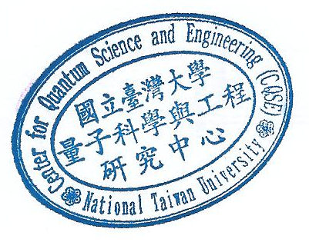
Dr. Lien-Po Yu is a technical director of the Institute for Information Industry (III, 資訊工業策進會) where he has assumed various responsibilities including the R&D staff management and project management of a number of government-commissioned projects on information and communication technology (ICT). Prior to joining the III, Dr. Yu has held several managerial and technical leadership roles at the Hon Hai Precision Industry Co., Ltd., (a.k.a. Foxconn Technology Group, 鴻海科技集團) and the National Chung-Shan Institute of Science and Technology (國家中山科學研究院) respectively where he has been devoted to the research and development of consumer electronics and military avionics systems, and engaged in multidisciplinary collaboration and teamwork with international partners from EU and US. His current research interests include quantum computing, quantum-inspired computing, system and software engineering, etc.

