Joint CQSE & NCTS Online Seminar

2021
Dec. 10, Friday

TIME Dec. 10, 2021, 2:30~3:30pm
TITLE Entanglement Spin Qubit: Variability and Versatility
SPEAKER Chien-Yuan Chang (Postdoctoral researcher, RIKEN Center for Quantum Computing)
LINK https://meet.google.com/odw-oosb-jpw

Abstract:

In this seminar, I will introduce the fundamental formation of spin qubit and its potential in integration of photonic qubit. First, quantum computing with single electron spin qubit is demonstrated via our recent progress in single- and two- qubit operation. Such demonstration will further motivate industrial incorporation for the qubit scale-up using semiconductor device processing technology. Secondly, we demonstrate entanglement transformation of entangled photon pairs by photo-excitation of single electron spin and observe its correlation with the remaining single photon from pairs of polarization-entangled photons. Both experiments show promises in achieving a large-scale quantum processing system.
Biography Brief:

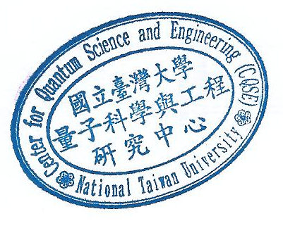
Chien-Yuan Chang is a postdoctoral researcher at Semiconductor Quantum Information Device Research Team and Quantum Functional System Research Group in RIKEN, Japan since 2019. Prior to this, CYC was a project researcher in the Tarucha Laboratory at the University of Tokyo (2018-2019). Prior to pivoting to Japan, he received his B. E. in Electrical Engineering from National Taiwan University (NTU) and his Ph. D degree in Physics and Georgia Institute of Technology, respectively. He worked with trapped-ion qubit (with Prof. Kenneth Brown), quantum stability analysis and coherent quantum feedback with photonic qubit (Prof. Loic Lanco, Prof. Pascale Senellart), and photonic information processing with nonlinear optics (Prof. David Citrin).

