Joint CQSE & NCTS Seminar

2021
Dec. 17, Friday

TIME Dec. 17, 2021, 2:30~3:30pm
TITLE Quantum walk finds a way for GKP!
SPEAKER Shin-Tza Wu (Associate Professor, Department of Physics, National Chung Cheng University)
PLACE Rm104, Chin-Pao Yang Lecture Hall,
CCMS & New Physics Building, NTU

Abstract:

In this talk, I will present a theoretical framework for encoding arbitrary logical states of a quantum bit into a continuous-variable quantum mode through quantum walks. Starting with a squeezed-vacuum state of the quantum mode, I will explain how quantum walks of the state in phase space can generate codewords that are variants of those proposed originally by Gottesman, Kitaev, and Preskill (GKP) [Phys. Rev. A 64 , 012310 (2001)]. In particular, with a coin-toss transformation that projects the quantum coin onto diagonal coin-state, the resulting nonunitary quantum walks can generate codewords akin to the prototypical GKP ones. Surprisingly, even without optimization, it is found that these codewords can outperform their GKP counterparts in error corrections by a narrow margin. Possible experimental realizations of this encoding scheme through circuit quantum electrodynamics systems will also be discussed.
Biography Brief:

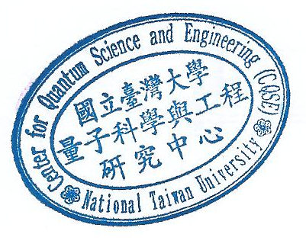
Shin-Tza Wu obtained his PhD from the University of Cambridge in 1999. After that, he went on as postdocs first at the Department of Physics at National Tsing-Huan University Hsinchu, and then at the Institute of Physics at Academia Sinica Taipei. In 2004, he joined the Department of Physics of National Chung Cheng University at Chiayi. Dr Wu had worked previously on theories related to cavity quantum electrodynamics, transports in superconducting junctions, and physics of ultracold atoms. In recent years, he has focused mainly on problems related to quantum information sciences, in particular, concerning their possible physical realizations.

