Joint CQSE & NCTS Seminar

2022
Feb. 25, Friday

TIME Feb. 25, 2022, 2:30~3:30pm
TITLE Decoding of topological quantum codes
SPEAKER Professor. Ching-Yi Lai (Assistant Professor, Department of Electronics and Electrical Engineering, National Yang Ming Chiao Tung University)
PLACE NCTS Physics Lecture Hall, 4F, Chee-Chun Leung Cosmology Hall, NTU

Abstract:

Quantum information needs to be protected by quantum error-correcting codes due to imperfect quantum devices and operations. One would like to have an efficient decoding procedure for practical quantum codes, such as toric and surface codes. Currently the state-of-the-art minimum-weight perfect matching decoder has complexity polynomial in the code distance; a decoder of complexity linear in the code distance is desired. A potential candidate is Pearl's belief propagation (BP), but its performance suffers from the many short cycles inherent in quantum codes. We show that BP can exploit the degeneracy of quantum codes and have significantly improved performance. In particular, we achieve a high decoding threshold (14~16%) for the surface codes in the ideal circuit model.
Biography Brief:
Ching-Yi Lai was born in Taipei, Taiwan. He received his MS in 2006 and BS in 2004 from the Department of Electrical Engineering, National Tsing-Hua University, Taiwan. He received his Ph.D. degree in 2013 from the Communication Sciences Institute, Electrical Engineering Department, University of Southern California. He joined the Centre for Quantum Software and Information, University of Technology Sydney as a postdoctoral research associate from December 2013 to July 2015. Then he was a postdoctoral scholar at the Institute of Information Science, Academia Sinica, Taiwan from September 2015 to July 2018.

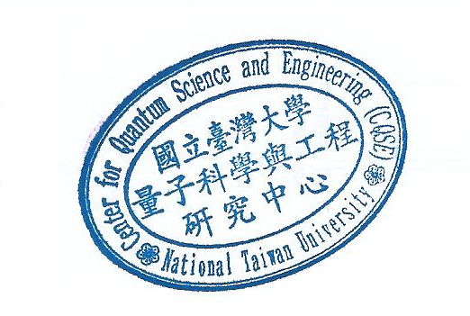
Dr. Lai is currently an Assistant Professor at the Institute of Communications Engineering, National Yang Ming Chiao Tung University, Hsinchu, Taiwan. He received the Young Scholar Fellowship from the Ministry of Science and Technology, Taiwan in 2018. His research interests include quantum error-correcting codes, quantum information theory, fault-tolerant quantum computation, and quantum cryptography.

