Joint CQSE & NCTS Seminar

2023
Mar. 31, Friday

TIME Mar. 31, 2023, 14:30~15:30pm
TITLE Revealing the mystery of strange metal states in correlated electron systems
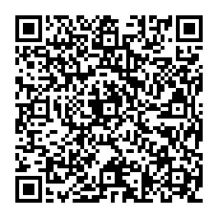
SPEAKER Prof. Chung-Hou Chung
(Department of Electrophysics, National Yang Ming Chiao Tung University)
PLACE NCTS Physics Lecture Hall, 4F, Chee-Chun Leung Cosmology Hall, NTU
ONLINE https://nationaltaiwanuniversity-zbn.my.webex.com/

Abstract:
A major mystery in strongly interacting quantum systems is the microscopic origin of the “strange metal” phenomenology, with unconventional metallic behavior that defies Landau’s Fermi liquid framework for ordinary metals. This state is found across a wide range of correlated quantum materials, including rare-earth intermetallic compounds and unconventional superconductors at finite temperatures (T) near a magnetic quantum phase transition. It shows a quasilinear-in-temperature resistivity and a logarithmic-in-temperature specific heat coefficient. In this talk, I will present two theoretical studies to reveal the mystery of strange metal state in CePd1−xNixAl, a geometrically frustrated Kondo lattice compound, as well as in Ce1−xNdxCoIn5, a heavy-electron quantum critical superconductor. (i) CePd1−xNixAl. Recently, an enigmatic behavior pointing toward a stable strange metal ground state (phase) was observed in CePd1−xNixAl. Here, we propose a mechanism for such phenomena driven by the interplay of the gapless fermionic short-ranged antiferromagnetic spin correlations (spinons) and critical bosonic charge (holons) fluctuations near a Kondo breakdown quantum phase transition [1]. Within a dynamical large-N approach to the Kondo–Heisenberg lattice model, the strange metal phase is realized in transport and thermodynamic quantities. It is manifested as a fluctuating Kondo-scattering–stabilized critical (gapless) fermionic spin-liquid metal. It shows ω/T scaling in dynamical electron scattering rate, a signature of quantum criticality. Our results offer a qualitative understanding of the CePd1−xNixAl compound [2] and suggest a possibility of realizing the quantum critical strange metal phase in correlated electron systems in general. (ii) Ce1−xNdxCoIn5. An even more mysterious Planckian metal state[3], a particular type of strange metal state, showing perfect T-linear resistivity associated with universal scattering rate, 1/τ = α kBT/ℏ with α ~ 1, has been observed in the normal state of various strongly correlated superconductors close to a quantum critical point. However, its microscopic origin and link to quantum criticality remains an outstanding open problem. Here, we observe quantum-critical T/B-scaling of the Planckian metal state in resistivity and heat capacity of heavy-electron superconductor Ce1−xNdxCoIn5 in magnetic fields near the edge of anti-ferromagnetism at the critical doping xc ~ 0.03. We present clear experimental evidences of Kondo hybridization being quantum critical at xc. We provide a generic microscopic mechanism to qualitatively account for this quantum critical Planckian state within the quasi-two dimensional Kondo-Heisenberg lattice model near Kondo breakdown transition. We find α is a non-universal constant and depends inversely on the square of Kondo hybridization strength [4]. Our observation and proposed mechanism offer the first microscopic understanding of the Planckian dissipation limit in a quantum critical system. The applications of our studies in these two systems for the understanding of the Planckian strange metal state observed in high-Tc cuprate superconductors are discussed.

*This work was supported by the MOST/NSTC and NCTS of Taiwan, R.O.C.
[1] J. Wang, Y-Y Chang, and C.-H. Chung*, A mechanism for for the strange metal phase in rare-earth intermetallic compounds, PNAS 119, e2116980119 (2022).
[2] H. Zhao et al., Nat. Phys. 15, 1261–1266 (2019).
[3] Legros, A. et al., Nat. Phys. 15, 142–147 (2019); Bruin, J. A. N., Sakai, H., Perry, R. S., Mackenzie, A. P. Science 339, 804–807 (2013).
[4] Yung-Yeh Chang, Hechang Lei, Cedomir Petrovic*, Chung-Hou Chung*, The scaled-invariant Planckian metal and quantum criticality in Ce_{1-x}Nd_{x}CoIn₅, Nature Communications 14 (581) (2023). https://doi.org/10.1038/s41467-023-36194-9

Biography Brief:
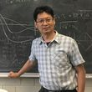
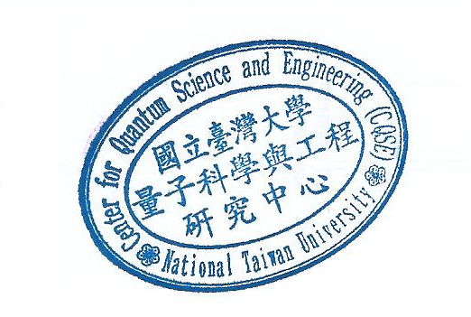
Chung-Hou Chung is a professor in Department of Electrophysics, National Yang Ming Chiao-Tung University, HsinChu, Taiwan. He received his PhD from Brown University, USA in 2002. He was a postdoctoral research associate at University of Toronto (2002-2004) and Karlsruhe Institute of Technology (KIT) (2004-2006), Germany before he joined the faculty at National Chiao-Tung University in 2006. His research interest is theoretical condensed matter physics with special focuses on quantum phase transitions and quantum critical phenomena in strongly correlated electron systems. He was a visiting scholar at Yale University, Rutgers University, Brookhaven National Laboratory, Kavli Institute of Theoretical Physics (KITP) at UCSB, the Max-Planck Institute for Complex Systems, Dresden, and International Center for Theoretical Physics (ICTP), Italy. His most well-known works include: 1. Prediction of an exotic valance-bond-solid phase of the frustrated anti-ferromagnet on two-dimensional Shastry-Sutherland lattice together with J.B. Marston and S. Sachdev in 2001, which was later realized experimentally in 2017. This work was highlighted by S. Sachdev in his Onsarger Prize talk in 2018; 2. Theory of quantum criticality in a double quantum dot system. It motivates extensive further theoretical and experimental studies; 3. Theory on non-equilibrium transport at a dissipative quantum phase transition, a pioneer work on a new research field: quantum phase transition out of equilibrium. 4. Theory of strange metal states in correlated electron systems. His research works were recognized both internationally via various invited talks in international conferences and in Taiwan by Outstanding Young Researcher Grant of NSC and the Center Scientist of the National Center for Theoretical Sciences (NCTS). He is the recipient of the 57th (2022) Sun Yat Sen Academic Writing Award.

