Joint CQSE & NCTS Seminar

2025
May 9, Friday

Time: May 9, 14:30 ~ 15:30
Title: Microwave memory based on quantum interference in a superconducting atom
Speaker: Prof. Yung-Fu Chen (Department of Physics, National Central University)
Place: NCTS Physics Lecture Hall, 4F, Chee-Chun Leung Cosmology Hall, NTU
Online Link: https://nationaltaiwanuniversity-zbh.my.webex.com/nationaltaiwanuniversity-zbh.my/j.php?MTID=m2a963d31adcf732fcddcf95022ff7210

Abstract:
Microwave quantum memory is a fundamental component for realizing large-scale quantum networks based on superconducting circuits. In this presentation, we report the experimental implementation of a microwave quantum memory based on electromagnetically induced transparency (EIT) in a superconducting artificial atom. The storage efficiency is currently limited by incomplete temporal compression of the input coherent microwave pulse within the single-atom medium and by bidirectional photon emission. To overcome these challenges, we propose a novel storage scheme employing a chiral artificial atom that harnesses quantum interference effects analogous to EIT. This architecture enables full temporal compression and enforces unidirectional emission, thereby achieving near-unity storage efficiency. Furthermore, we introduce a deterministic single-photon source capable of generating shaped pulse profiles, establishing a platform for future studies on the interaction between microwave quantum memories and genuine quantum light. Our ongoing efforts focus on enhancing the storage efficiency and fidelity of the memory system, as well as investigating its response to non-classical light fields.
Biography:
Yung-Fu Chen
Education
Ph.D. in Physics, University of Maryland, College Park (08/2000 – 04/2006)
B.S. in Physics, National Taiwan University (10/1994 – 06/1998)

Work Experience
Professor
Department of Physics, National Central University (08/2023 – present)
Associate Professor
Department of Physics, National Central University (08/2017 – 07/2023)
Assistant Professor
Department of Physics, National Central University (08/2011 – 07/2017)
Postdoctoral Research Associate
Department of Physics, University of Wisconsin-Madison (05/2009 – 06/2011)
Postdoctoral Research Associate
Department of Physics and Materials Research Laboratory, University of Illinois at Urbana-Champaign (05/2006 – 05/2009)

Recent Research Focus
Superconducting circuits
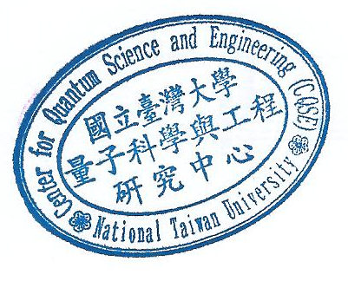
Quantum control and sensing

