Joint CQSE & NCTS Seminar

2024
Mar. 15, Friday

TIME Mar. 15, 2024, 14:30~15:30 pm
TITLE Distillation of steering and impossible distillation of measurement incompatibility under local filters
SPEAKER Prof. Huan-Yu, Ku (Department of Physics, National Taiwan Normal University)
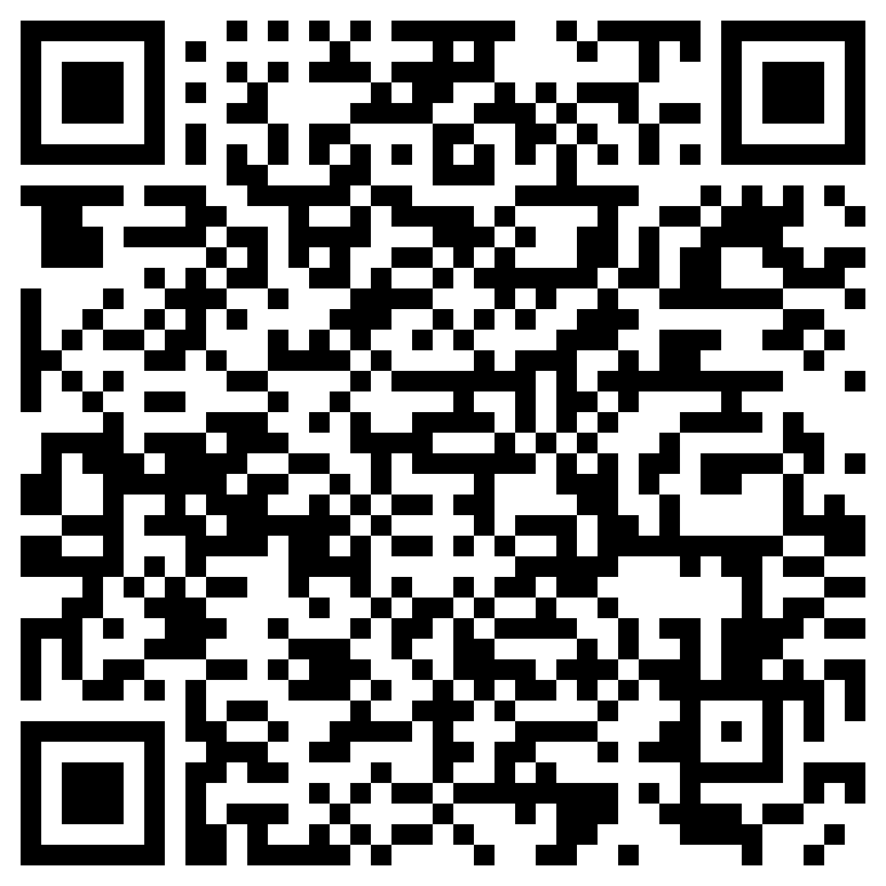
PLACE NCTS Physics Lecture Hall, 4F, Chee-Chun Leung Cosmology Hall, NTU
ONLINE https://nationaltaiwanuniversity-zbn.my.webex.com/

Abstract:
Quantum steering is a central resource for one-sided device-independent quantum information. It is manipulated via one-way local operations and classical communication, such as local filtering on the trusted party. Here, we provide a necessary and sufficient condition for a steering assemblage to be transformable into another via local filtering. We characterize the equivalence classes with respect to filters in terms of the steering equivalent observables (SEO), first proposed to connect the problem of steerability and measurement incompatibility. We provide an efficient method to compute the extractable steerability that is maximal via local filters and show that it coincides with the incompatibility of the SEO. We also show that measurement incompatibility cannot be distilled under the filtering operation.

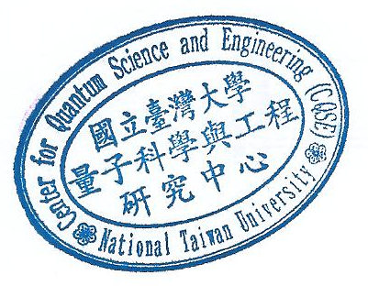

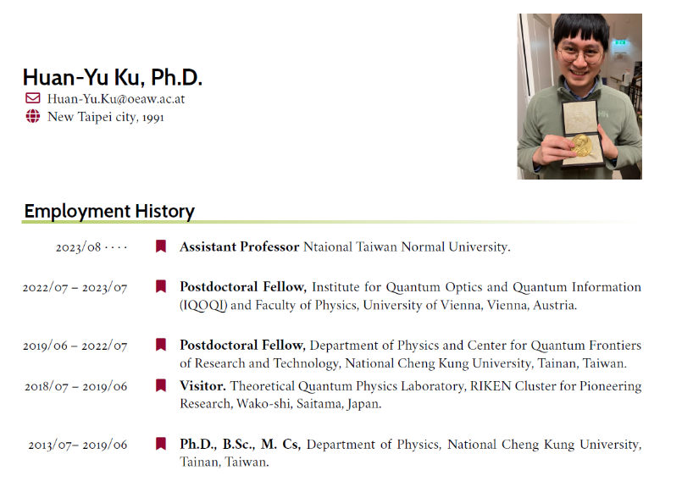
Biography Brief:

