Joint CQSE & NCTS Seminar

2022
Dec. 23, Friday

TIME Dec. 23, 2022, 14:30~15:30pm
TITLE Experimental Realization of Superconducting Qubits
SPEAKER Researcher Chii-Dong Chen (Institute of Physics, Academia Sinica)
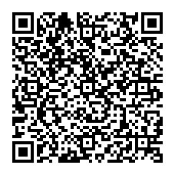
PLACE Rm104, Chin-Pao Yang Lecture Hall, CCMS & New Physics Building, NTU
ONLINE https://nationaltaiwanuniversity-zbn.my.webex.com/

Abstract:
Quantum computers are a new generation of quantum technology, and the qubit is the building component of quantum computers. There are several manifestations of qubits. Among them, the superconducting qubit is one of the relatively mature forms. In this talk, I will introduce the realization of superconducting qubits, including considerations in chip design, manufacturing, and circuits for control and readout of qubit states.

Biography Brief:
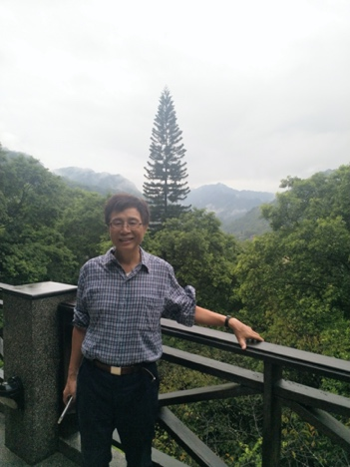
ChiiDong Chen received his PhD degree from the Department of Physics, Chalmers University of Technology, Sweden, where he studied Superconductor-Insulator Phase Transitions in 2D arrays of small Josephson junctions. After graduated, he moved to NEC fundamental research laboratories, Tsukuba, Japan serving as a postdoc, there he studied Cooper-pair tunneling in Superconducting Single-Electron-Transistors. In 1997, he joined the Institute of Physics, Academia Sinica as a faculty member. His research interests span a broad range in the fields of superconducting devices as well as mesoscopic devices comprising 2D materials. His recent research topic is on the superconducting qubits.
