Joint CQSE & NCTS Special Seminar

2022
Nov. 18, Friday

TIME Nov. 18, 2022, 2:30~3:30pm
TITLE Bridging classical and quantum computation: from tensor network to quantum circuit
SPEAKER Professor, Po-Chung Chen (Department of Physics, National Tsing Hua University)
PLACE Rm104, Chin-Pao Yang Lecture Hall,
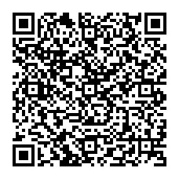
CCMS & New Physics Building, NTU
ONLINE https://nationaltaiwanuniversity-zbn.my.webex.com/

Abstract:
In this talk, I first introduce the concept of tensor network and explain why tensor network is the best classical simulation framework for quantum many-body systems.
Then I introduce the perspective of viewing quantum circuit as a restricted subclass of tensor networks and argue that tensor network is natural language to bridge the classical and quantum computations. This bridge leads to many possibilities to achieve quantum advantage using NISQ devices.
For example, one can promote a tensor network to a quantum circuit tensor network by replacing the unitaries and isometries by local quantum circuits. Or, one can port classical tensor network algorithms to finite-depth quantum circuit machines. Yet another potential is to use classical tensor network simulations to identify a good initial quantum state, convert the state to the parameters of a parameterized quantum circuit, then perform further optimization on quantum hardware.
Biography Brief:
Prof. Pochung Chen received his PhD degree from the Physics Department, University of California San Diego, USA in 2002. He joined the Department of Physics, National Tsing Hua University, Taiwan in 2004 and was promoted to the full professor in 2014.
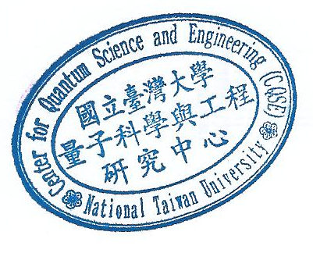
His is a computational condensed matter physicist. He has been applying tensor network algorithms to various strongly correlated many-body systems. He has also been working on bridging the tensor network and quantum circuit to explore the quantum advantage in the NISQ era.

