Joint CQSE & NCTS Special Seminar

2022
Dec. 13, Tuesday

TIME Dec. 13, 2022, 12:30~13:30pm
TITLE Variational Quantum Circuits as Machine Learning Models
SPEAKER Dr. Yen-Chi Chen (Senior software engineer at Wells Fargo Bank)
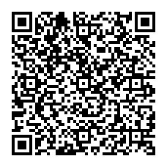
PLACE NCTS Physics Lecture Hall, 4F, Chee-Chun Leung Cosmology Hall, NTU
ONLINE https://nationaltaiwanuniversity-zbn.my.webex.com/

Abstract:
Quantum machine learning (QML) is an emerging research field combining quantum computing and machine learning to solve challenging tasks. Variational quantum circuits (VQC) is a leading framework to build QML models for near-term quantum devices. In this talk, I will describe the fundamentals behind this paradigm and provide several examples. Promising research directions in this field will also be discussed.

Biography Brief:
Dr. Samuel Yen-Chi Chen received the Ph.D. and B.S. degree in physics and the M.D. degree in medicine from National Taiwan University, Taipei City, Taiwan. He is now a senior software engineer at Wells Fargo Bank. Prior to that, he was an assistant computational scientist in the Computational Science Initiative, Brookhaven National Laboratory. His research interests include building quantum machine learning algorithms as well as applying classical machine learning techniques to solve quantum computing problems. He won the First Prize In the Software Competition (Research Category) from Xanadu Quantum Technologies, in 2019.

