Joint CQSE & NCTS Seminar

2023
Mar. 24, Friday

TIME Mar. 24, 2023, 14:30~15:30pm
TITLE On the path of using small quantum computers for practical purposes
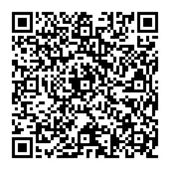
SPEAKER Chen-Yu Liu
(Department of Physics, National Taiwan University)
PLACE NCTS Physics Lecture Hall, 4F, Chee-Chun Leung Cosmology Hall, NTU
ONLINE https://nationaltaiwanuniversity-zbn.my.webex.com/

Abstract:
Quantum computers provide possible advantages over classical computer due to its superposition nature. However, in the NISQ era, the hardware is limited by the noise and the scalability. Thus, it is crucial to combine the available quantum computing resources with classical computational techniques for practical use. In this talk, we will mainly focus on the strategies to make the quantum computers with few qubits capable to deal with combinatorial optimization problems with lots of variables, as well as some machine learning techniques that could help for this purpose.

Biography Brief:
Chen-Yu Liu is currently a PhD candidate at the Graduate Institute of Applied Physics, National Taiwan University, supervised by Prof. Hsi-Sheng Goan. He got his BS degree in National Dong Hwa University (2018) and received his MS degree in National Tsing Hua University (2020). He was an apprentice quantum researcher at the Entropica Labs, prior to his PhD program. His current research interest includes quantum optimization and machine learning for quantum computing.

