Joint CQSE & NCTS online Seminar

2022
Mar. 18, Friday

TIME Mar. 18, 2022, 2:30~3:30pm
TITLE Hybrid Quantum-Classical Machine Learning with Tensor Networks
SPEAKER Dr. Yen-Chi Chen (Computational Science Initiative, Brookhaven National Laboratory)
PLACE Online Link: https://nationaltaiwanuniversity-zbh.my.webex.com/nationaltaiwanuniversity-zbh.my/j.php?MTID=m3efd6c4a404b85f1e7a186a89d9b9009

Abstract:
Recent advances in machine learning (ML) and quantum computing (QC) hardware draw significant attention to building quantum machine learning (QML) applications. One of the challenges is that the scale of existing quantum devices is small and special methods are required to preprocess or compress the large-dimensional inputs. The choice of such dimensional reduction method plays a crucial role in the performance of QML. In this talk, I will first provide a quick overview of the hybrid quantum-classical machine learning paradigm. Then I will present the recent progress of tensor network (TN) based dimensional reduction methods used in QML. Specifically, the hybrid TN-VQC models in both supervised learning (classification) tasks and reinforcement learning will be described. Potential advantage and scalability in the NISQ era will be discussed as well.

Biography Brief:
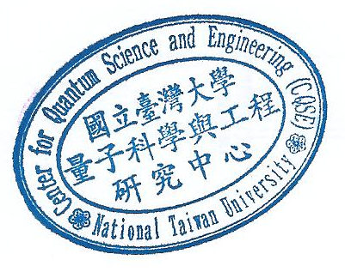
Dr. Yen-Chi Chen received the Ph.D. and B.S. degree in physics and the M.D. degree in medicine from National Taiwan University, Taipei City, Taiwan. He is now an assistant computational scientist in the Computational Science Initiative, Brookhaven National Laboratory. His research interests include building quantum machine learning algorithms as well as applying classical machine learning techniques to solve quantum computing problems. He was a recipient of the Theoretical Physics Fellowship from the National Taiwan University Center for Theoretical Physics, in 2015, and the First Prize In the Software Competition (Research Category) from Xanadu Quantum Technologies, in 2019.

