Joint CQSE & NCTS Seminar

2024
Mar. 01, Friday

TIME Mar. 01, 2024, 14:30~15:30 pm
TITLE Modeling static and dynamical properties of a 2DEG
in an external magnetic field and a FIR-photon cavity
SPEAKER Prof. Vidar Gudmundsson (Department of Physics, University of Iceland)
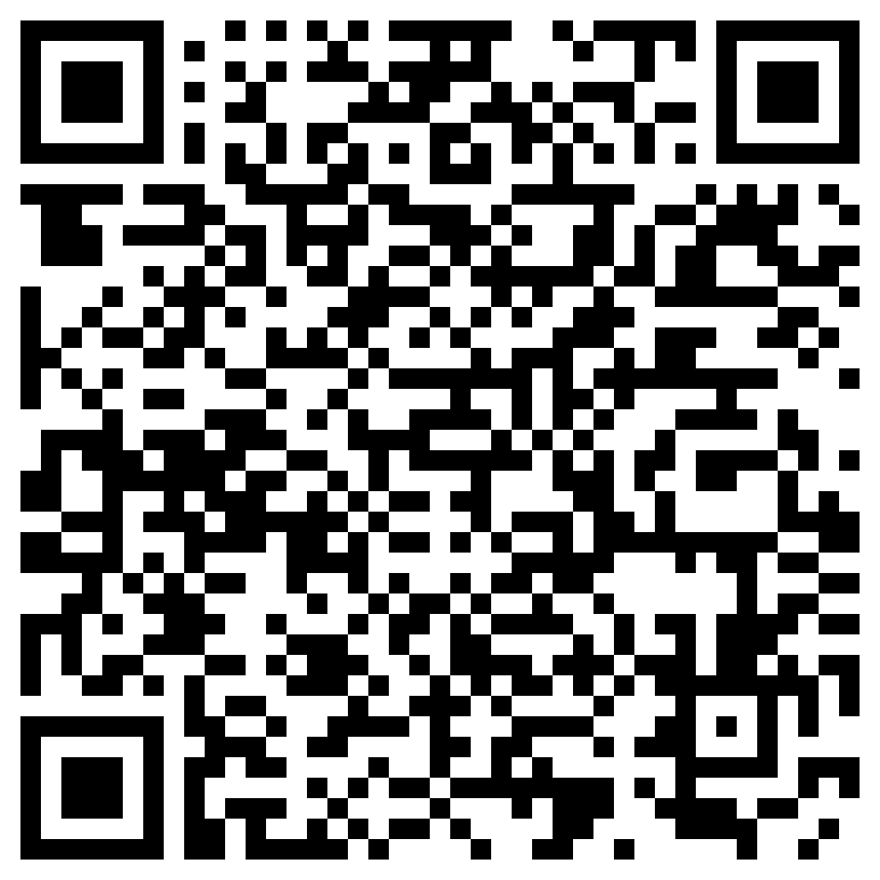
PLACE NCTS Physics Lecture Hall, 4F, Chee-Chun Leung Cosmology Hall, NTU
ONLINE https://nationaltaiwanuniversity-zbn.my.webex.com/

Abstract:
I will show why and how we have used quantum electrodynamical density functional theory (QEDFT) to model equilibrium and non-equilibrium properties of a two-dimensional electron gas of an array of quantum dots in a GaAs heterostructure and a far-infrared (FIR) photon microcavity. The results predict changes to the orbital magnetization and a red-shift various excitation modes of the 2DEG depending on the number of electrons in a dot, the electron-photon coupling, and the strength of the magnetic field.
I will outline how the results, and the comparison to our earlier CI (configuration interaction) approach for small electron-photon systems is leading us in a direction to describe the electron photon interaction beyond DFT.
Biography Brief:
Vita:
University of Iceland B.Sc. in physics 1978
University of Alberta, M.Sc. in theoretical physics 1980.
Supervisor Prof. M. Razavy.
University of Alberta, Ph.D. in theoretical physics 1985.
Supervisor Prof. Y. Takahashi.
Max-Planck Institute for Solid State Research, Stuttgart, postdoc, group of Prof. Klaus von Klitzing 1985-1988.
University of Iceland, Physics Department, 1988 -


